# 

# USAMA SHAHID | 4214832

# DATA ANALYSIS AND VISUALIZATION REPORT

# Crown Prosecution Service Case Outcomes

**Table of Contents**

**1. Executive Summary** **8**

**2. Data Overview** **9**

**3. Data Integration** **10**

3.1. Utilized Code 10

3.1.1. get_all_files_from_directories 10

3.1.2. merge_files 11

3.2. Integrated Dataset Shape 12

**4. Data Pre-process** **13**

4.1. Data Cleaning 13

4.1.1. Dropping Percentage Columns 13

4.1.1.1. Code 13

4.1.2. Add & Sort By Date 14

4.1.2.1. Code 14

4.1.3. Shifting Columns 15

4.1.3.1. Code 15

4.1.4. Rename Columns 15

4.1.4.1. Code 15

4.1.5. Remove Special Characters and Convert to Integer 16

4.1.5.1. Code 16

4.1.6. Rename Month Values 16

4.1.6.1. Code 17

4.1.7. Missing Data 17

4.1.7.1. Code 18

4.1.8. Label Region Based on County 18

4.1.8.1. Code 20

4.1.9. Shift Last Column to 5th Index 21

4.1.9.1. Code 21

4.1.10. Rename Conviction Columns 21

4.1.10.1. Code 22

4.2. Dataset Post Cleaning 22

4.2.1. Glimpse 22

4.2.2. Visualizing Missing 23

4.2.3. Visualizing Data Types 24

4.3. Dataset Split 25

4.3.1. Crime Dataset Glimpse 26

4.3.2. Unsuccessful Crime Dataset Glimpse 26

4.4. Code 26

**5. Descriptive Analytics** **28**

5.1. Attributes Analysis 29

5.1.1. Crimes Dataset 29

5.1.1.1. County 29

5.1.1.2. Year 29

5.1.1.3. Month 29

5.1.1.4. Yearmon 29

5.1.1.5. Region 30

5.1.1.6. Homicide 30

5.1.1.7. Offences_against_the_person 30

5.1.1.8. Sexual_offences 30

5.1.1.9. Burglary 31

5.1.1.10. Robbery 31

5.1.1.11. Theft_and_handling 31

5.1.1.12. Fraud_and_forgery 32

5.1.1.13. Criminal_damage 32

5.1.1.14. Drugs_offences 32

5.1.1.15. Public_order_offences 32

5.1.1.16. All_other_offences__excluding_motoring_ 33

5.1.1.17. Motoring_offences 33

5.1.2. Unsuccessful Crimes Dataset 33

5.1.2.1. County 33

5.1.2.2. Year 34

5.1.2.3. Month 34

5.1.2.4. Yearmon 34

5.1.2.5. Region 34

5.1.2.6. Homicide_us 34

5.1.2.7. Offences_against_the_person_us 35

5.1.2.8. Sexual_offences_us 35

5.1.2.9. Burglary_us 35

5.1.2.10. Robbery_us 35

5.1.2.11. Theft_and_handling_us 36

5.1.2.12. Fraud_and_forgery_us 36

5.1.2.13. Criminal_damage_us 36

5.1.2.14. Drugs_offences_us 37

5.1.2.15. Public_order_offences_us 37

5.1.2.16. All_other_offences__excluding_motoring__us 37

5.1.2.17. Motoring_offences_us 37

5.1.2.18. Admin_finalised_us 38

5.2. Analysis dependent on Regions 38

5.2.1. Region & All Types 38

5.2.1.1. Crimes 38

5.2.1.2. Unsuccessful Crimes 39

5.2.1.3. Code 40

5.2.2. Region & Sum of All 40

5.2.2.1. Crimes 41

5.2.2.2. Unsuccessful Crimes 41

5.2.2.3. Code 42

5.3. Analysis dependent on Years & Months 42

5.3.1. 2014 43

5.3.1.1. Crimes 43

5.3.1.2. Unsuccessful Crimes 44

5.3.2. 2015 45

5.3.2.1. Crimes 45

5.3.2.2. Unsuccessful Crimes 46

5.3.3. 2016 47

5.3.3.1. Crimes 47

5.3.3.2. Unsuccessful Crimes 48

5.3.4. 2017 49

5.3.4.1. Crimes 49

5.3.4.2. Unsuccessful Crimes 50

5.3.5. 2018 51

5.3.5.1. Crimes 51

5.3.5.2. Unsuccessful Crimes 52

5.3.6. Code 52

5.3.6.1. group_by_year_month 52

5.3.6.2. plot_graph 53

5.4. Analysis between Crime Types 53

5.4.1. Correlation 54

5.4.1.1. Crimes 55

5.4.1.2. Unsuccessful Crimes 57

5.4.1.3. Code 58

5.4.2. Covariance 59

5.4.2.1. Crimes 60

5.4.2.2. Unsuccessful Crimes 62

5.4.2.3. Code 63

5.5. Trend Analysis for Successful & Unsuccessful Crimes 64

5.5.1. Visualization 65

5.5.2. Code 66

**6. Predictive Analytics** **68**

6.1. Regression 68

6.1.1. Linear Regression 68

6.1.1.1. Dataset Summary 69

6.1.1.1.1. Train 69

6.1.1.1.2. Test 69

6.1.1.2. Model Summary 70

6.1.1.3. Accuracy Matrix 72

6.1.1.4. Predicted vs Actual Plot 73

6.1.1.5. Evaluating Stats 73

6.1.1.6. Code 74

6.1.1.6.1. Split Data 74

6.1.1.6.2. Linear Regression 75

6.1.2. Multiple Regression 75

6.1.2.1. Dataset Summary 76

6.1.2.1.1. Train 76

6.1.2.1.2. Test 76

6.1.2.2. Model Summary 77

6.1.2.3. Model Accuracy 79

6.1.2.4. Actual vs Predicted Plot 80

6.1.2.5. Evaluating Stats 81

6.1.2.6. Code 81

6.1.2.6.1. Split Data 81

6.1.2.6.2. Multiple Regression 82

6.2. Clustering 82

6.2.1. KMeans 83

6.2.1.1. Dataset Summary 83

6.2.1.2. With 4 Clusters 84

6.2.1.3. With 5 Clusters 85

6.2.1.4. With 6 Clusters 86

6.2.1.5. Summary 86

6.2.1.6. Code 87

6.2.1.6.1. Remove Non Numeric Columns 87

6.2.1.6.2. K Means Clustering 87

6.2.2. Hierarchical Clustering 88

6.2.2.1. Data Summary 88

6.2.2.2. Cluster Dendrogram 89

6.2.2.3. Dendrogram with 2 Clusters 90

6.2.2.4. Dendrogram with 3 Clusters 91

6.2.2.5. Dendrogram with 5 Clusters 92

6.2.2.6. Dendrogram with 8 Clusters 93

6.2.2.7. Dendrogram with 11 Clusters 94

6.2.2.7.1. Code 94

6.2.2.7.2. Group By Country 94

6.2.2.7.3. HC Clustering 95

6.3. Classification 95

6.3.1. SVM 95

6.3.1.1. Dataset Summary 95

6.3.1.1.1. Train 95

6.3.1.1.2. Test 96

6.3.1.2. Model Summary 96

6.3.1.3. Classification Report 96

6.3.1.4. Model Roc 98

6.3.1.5. Code 98

6.3.1.5.1. SVM Model Generate 98

6.3.2. Random Forest 99

6.3.2.1. Dataset Summary 99

6.3.2.1.1. Train 99

6.3.2.1.2. Test 99

6.3.2.2. Model Summary 100

6.3.2.3. Classification Report 100

6.3.2.4. Model Roc 102

6.3.2.5. Code 102

6.3.2.5.1. Rf Model Generate 102

6.3.3. Summary 103

6.3.4. Joint Code 103

**7. Time Series Analytics** **105**

7.0.1. Crime 105

7.0.1.1. Dataset Summary 105

7.0.1.1.1. Data Frame 105

7.0.1.1.2. Time Series 106

7.0.1.2. Time Series Data Plot 107

7.0.1.3. Filling Missing Data with Mice 108

7.0.1.3.1. Mice Summary 108

7.0.1.3.2. Mice Filled Data 108

7.0.1.4. Filled Time Series Data Plot 109

7.0.1.5. Data Patterns Check 110

7.0.1.6. Diagnostic Check 110

7.0.1.6.1. Residuals 111

7.0.1.6.2. Box-Ljung test 111

7.0.1.7. Forecasting 112

7.0.1.7.1. Years 112

7.0.1.7.2. Years 113

7.0.2. Un successful Crimes 114

7.0.2.1. Dataset Summary 114

7.0.2.1.1. Data Frame 114

7.0.2.1.2. Time Series 114

7.0.2.2. Time Series Data Plot 115

7.0.2.3. Filling Missing Data with Mice 116

7.0.2.3.1. Mice Summary 116

7.0.2.3.2. Mice Filled Data 117

7.0.2.4. Filled Time Series Data Plot 118

7.0.2.5. Data Patterns Check 119

7.0.2.6. Diagnostic Check 120

7.0.2.6.1. Residuals 120

7.0.2.6.2. Box-Ljung test 120

7.0.2.7. Forecasting 121

7.0.2.7.1. Years 121

7.0.2.7.2. Years 122

7.0.3. Summary 122

7.0.4. Joint Code 122

7.0.4.0.1. Check and Add Missing Rows with NA 122

7.0.4.0.2. Convert to Time Series 123

**8. References** **123**

# 

# 1. Executive Summary

The data utilized to construct this analysis was derived from an uneven array of months; while those appended to the various years involved do not feature in their archive, they have nevertheless been taken into consideration.

In this analytics report, data exportation and integration were performed. Subsequently, an intensive cleaning of the desired data structure and methodology for performing a descriptive analysis, predictive analytics and prescriptive with hypothesis testing at each stage of analysis.

# 2. Data Overview

The dataset utilized for this report is the Crown Prosecution Service Case Outcomes by Principal Offense Category (POC) obtained from data.gov.uk website. The CPS outcomes are categorized into convictions and unsuccessful verdicts, with data spanning from 2014 to 2018 collected on a monthly basis in forty-two (42) counties throughout England where applicable.

The convictions comprise of guilty pleas, trials resulting in convictions and verdicts rendered against respondents who have not appeared in court. An incomplete outcome encompasses all other categories, equally comprising discontinuances and withdrawals; discharged committals; dismissals or acquittals; as well as administrative finalizations.

The offenses recorded comprise homicide, violations against the person such as sexual assault, burglary, robbery and theft; in addition to handling fraud or forgery along with criminal damage committed to public places and automobiles. All other offenses except motoring-related offenses are included within this category.

# 3. Data Integration

The dataset was scattered in the shape of directories for each year whereas each directory contained all possible months data for the parent directory representing the year. In response to the dataset shape, the chosen strategy was to first write a generic function that reads all possible files within the directories and create a hashmap. Afterwards, another function that reads the hashmap and merges all the files into a singular dataframe and within the process it creates columns for year and month extracted from the directory name and the file name respectively.

## 3.1. Utilized Code

The sections below contain each operation's code and description respectively.

### **3.1.1.** G**et_all_files_from_directories**

This function is used to fetch all the files listed under specified directories and return a hash containing directories and filenames.

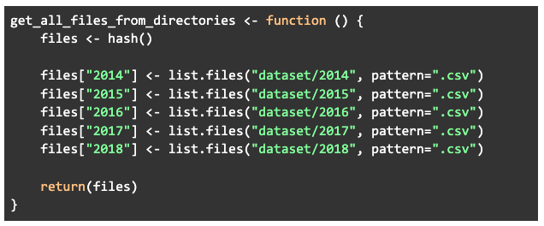

### 3.1.2. Merge_files

The code takes input of a hashmap, reads and merges all the files into one dataframe by creating appropriate columns to distinguish data.

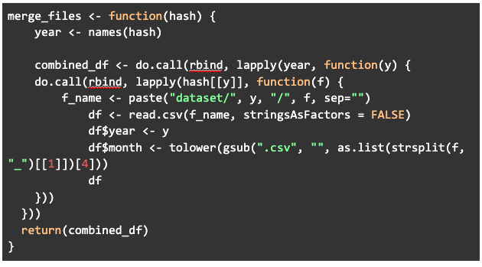

## 3.2. Integrated Dataset Shape

After the integration was conducted, the dataset took the following structure as shared below.

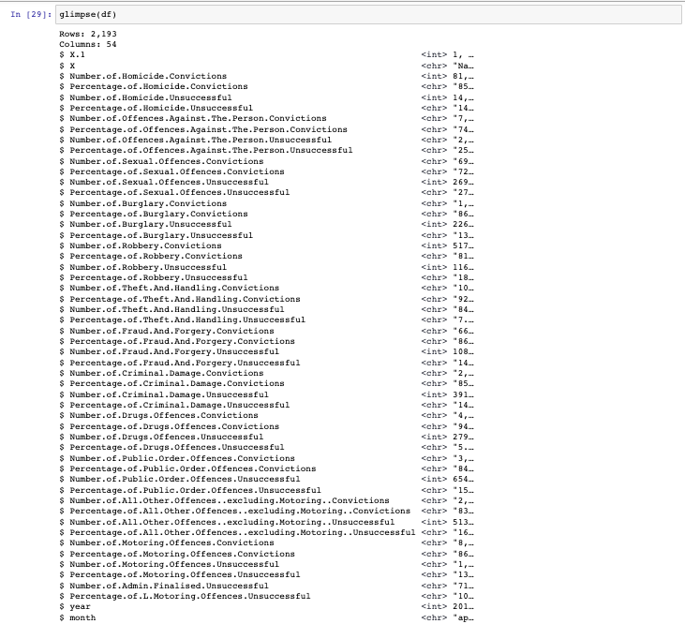

# 4. Data Pre-process

In order to carry out all data analytics with accurate results as well as to enable all the statistical algorithm’s smooth working, a series of data pre-processing steps are performed to make sure the data is converted into highest quality. We would first look at each step one by one with reasoning and impact. Along with that, we would explore the code utilized to execute each operation.

## 4.1. Data Cleaning

Data cleaning is the process of identifying and correcting or removing inaccuracies and inconsistencies in data. This process is important for data analytics because it ensures that the data being analyzed is accurate and reliable, which in turn leads to more accurate and reliable insights. Without proper data cleaning, the results of data analysis may be misleading or incorrect. Additionally, data cleaning can also make the data more usable by removing unnecessary information and making it more consistent. This can make it easier and more efficient to work with the data. The sections below contain each operation performed with reasoning and impact.

### 4.1.1. Dropping Percentage Columns

By removing these columns, the data set is made more manageable and the analysis can be focused on the most important variables. Additionally, percentage columns can be dropped when the data is skewed, which can cause problems in modeling and can lead to inaccurate results. Moreover, if required they can be re-generated using other attributes.

#### **4.1.1.1. Code**

The functions drops all the columns that keyword “Percentage” in their column name from the dataframe.

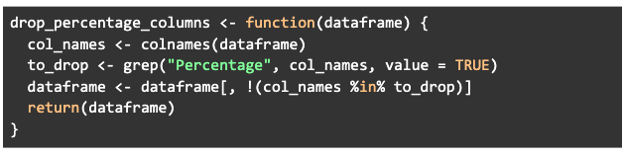

### 4.1.2. Add & Sort By Date

This data cleaning operation is adding a new column to the dataset that combines the year and month columns, creating a date field. This can be useful for sorting the dataset by the date field, making it easier to analyze the data over time. The impact of this operation is that it will make the dataset more easily readable and usable for analysis by adding a date field, and it will sort the data by that field, which can make it easier to track trends over time. The reasoning behind this is to make the data more usable and to make it easier to track patterns and trends over time.

#### **4.1.2.1. Code**

The function creates a new column based of year & month and sorts the dataframe based of that column.

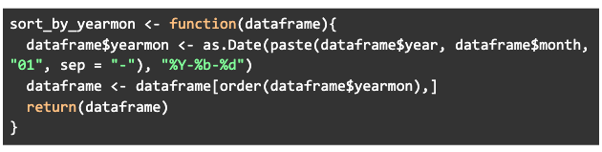

### 4.1.3. Shifting Columns

This operation is used to re-organize the data set to make it easier to navigate, read, understand, interpret and utilize.

#### **4.1.3.1. Code**

The function shifts the last two columns after the first column.

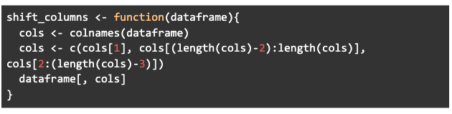

### 4.1.4. Rename Columns

This operation is used to remove repetitive text from the column names to make them more shorter, readable and easier to use as well as visualize during various analyses.

#### **4.1.4.1. Code**

The function removes repetitive keywords like “Number.of.” from the column names and renames them.

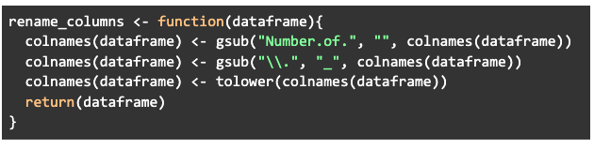

### 4.1.5. Remove Special Characters and Convert to Integer

This operation removes any unnecessary text such as “,” within the column values and converts them into integer type so they can be used easily during data analysis. Most of the models require integer input or some perform better within the format. Mainly, the base nature of these columns should be Integer.

#### **4.1.5.1. Code**

The function is used to remove special characters and convert most of the data frame columns to integer type.

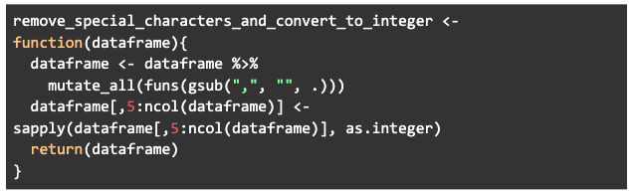

### 4.1.6. Rename Month Values

As shown in the figure below, there were multiple representations of a single month within the dataframe which were considered as different months when they represented the same month. This operation makes sure that all the months are converted into a singular format to remove noise.



#### **4.1.6.1. Code**

The code renames the month values to have a consistent format.

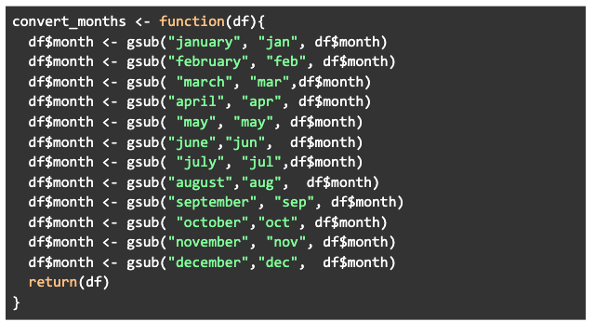

### 4.1.7. Missing Data

This column visualizes the missing months within respective years that are missing from the dataset. The data wasn’t imputed as in time series when the missing data is not missing at random, or when there are no strong assumptions about how the missing data is generated. In this case, imputing data may introduce bias in the data, leading to inaccurate analysis. Also, imputing the data may not be able to provide accurate results. So, at the earlier stage of analysis the missing data is left as it is but we impute it at later stage of analysis as required.

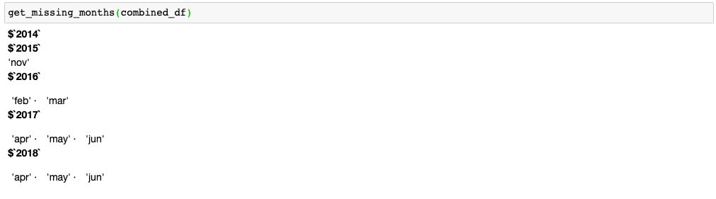

#### **4.1.7.1. Code**

The function returns all the missing data of months under the respective year.

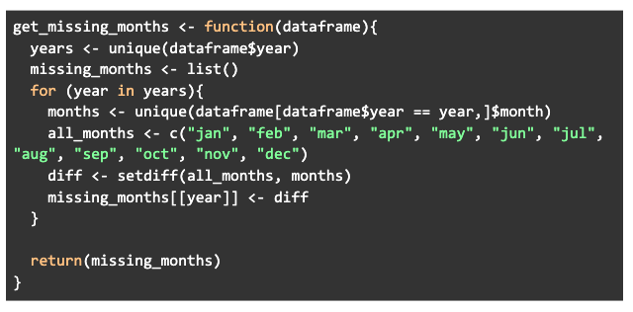

### 4.1.8. Label Region Based on County

This operation is creating a new column in the dataframe called "region" and assigning values to it based on the values of the "county" column. The values are being determined by using the county_region_map list as a lookup table. This can be useful for grouping and analyzing the data by region, rather than individual counties. It can also be useful for creating aggregate statistics for regions, rather than individual counties. Additionally, it will make the data more organized and readable, allowing for more efficient analysis. The impact of this operation is that it will add a new level of analysis to the data, by dividing the county data into regions. The reasoning behind this is to make the data more usable and to make it easier to track patterns and trends for regions, which can be more meaningful for some analysis.



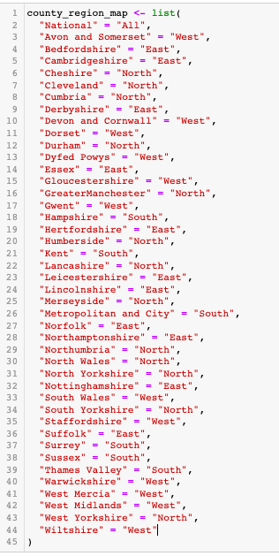

#### **4.1.8.1. Code**

The function creates a new column named region and labels values based on input map and existing county column values.

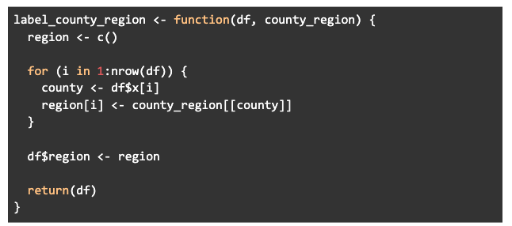

### 4.1.9. Shift Last Column to 5th Index

This functions changes the order of columns in the dataset to make it easier to manage and utilize.

#### **4.1.9.1. Code**

This function takes a dataframe as input and moves the last column to the 5th position and returns the modified dataframe.

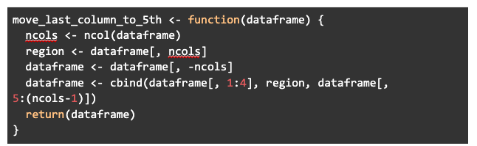

### 4.1.10. Rename Conviction Columns

This operation was too used to make column names even shorter by removing “convictions” from the crime columns names and converting “unsuccessful” into a short form of “us” in the column names.

#### **4.1.10.1. Code**

This function renames the columns of a dataframe, removing the "_convictions" and "_unsuccessful" substrings from the column names and replacing the latter with "_us" if it exists.

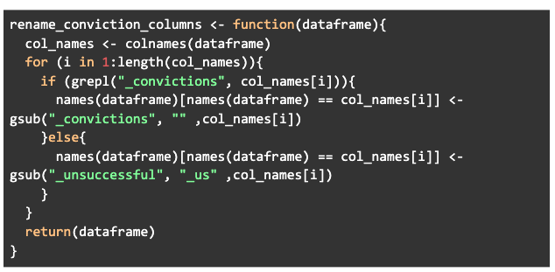

## **4.2.** Dataset Post Cleaning

After all of the steps have been performed the dataset takes shape as visualized in the below sections.

### 4.2.1. Glimpse

The glimpse() function in R is a part of the dplyr package and it provides a quick and easy way to look at the structure and first few rows of a dataframe or tibble. It is useful for quickly checking the structure and contents of a dataframe without having to print the entire dataset.

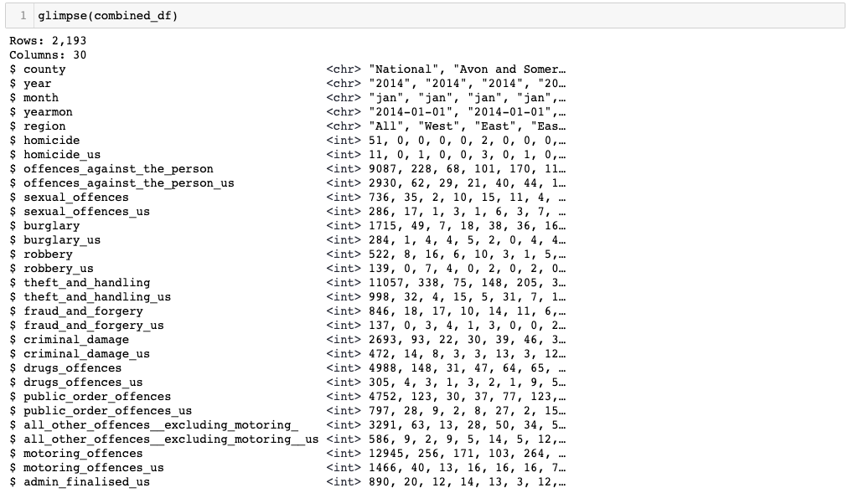

### 4.2.2. Visualizing Missing

All of the rows have complete data and there are no Nulls or NaNs within the dataset.

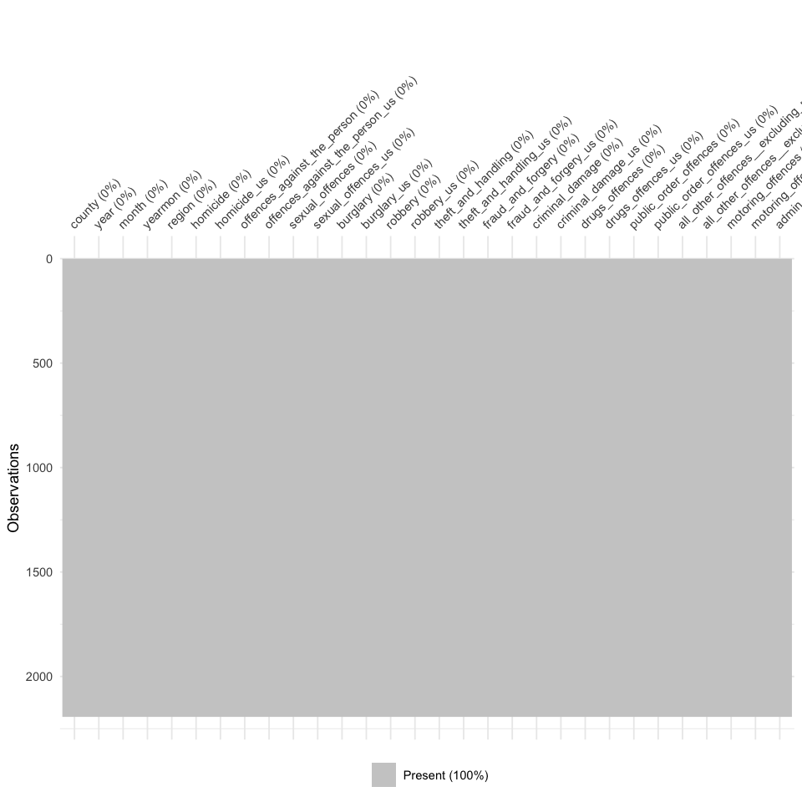

### 4.2.3. Visualizing Data Types

All of the successful and unsuccessful crime columns are successfully converted into Integer types which basically compose 80% of the dataframe and 20% person belongs to other columns.

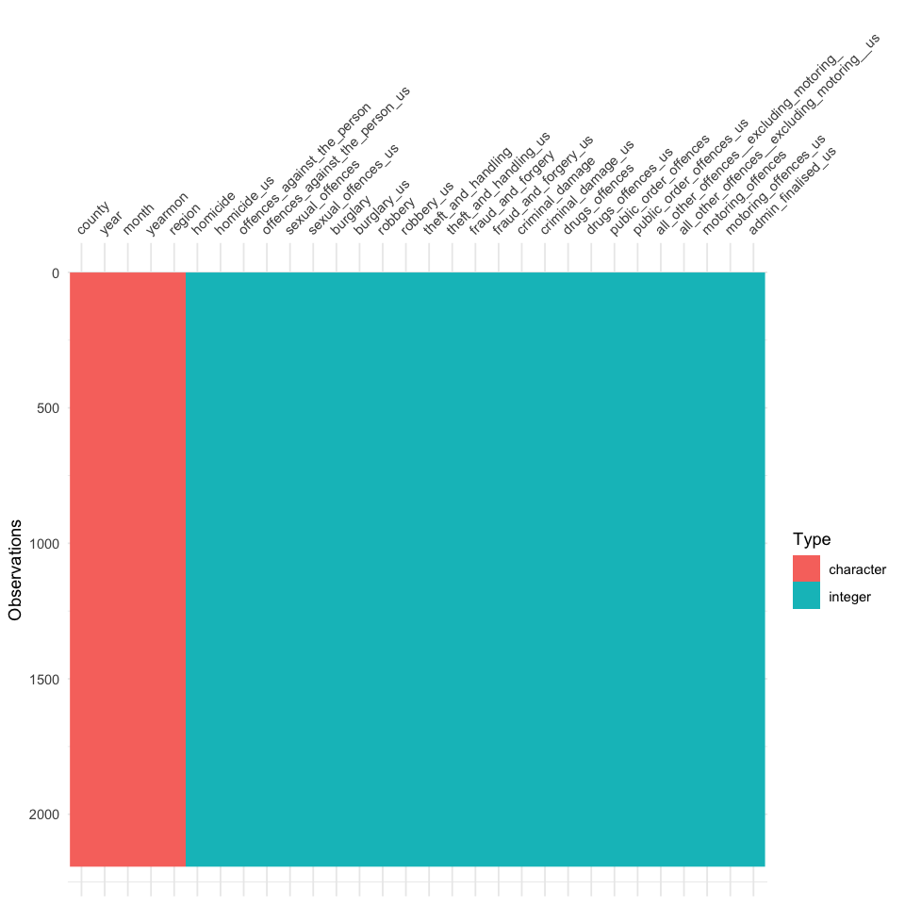

## 4.3. Dataset Split

As our dataset had two major types of integer columns, we split the data based on it. The two main categories are Crimes and Un-successful crimes. By splitting the dataset, we can eradicate the repetitive filtering operation during the analysis and also provide a more focused baseline for making hypothesis or conducting any analysis operation.

### 4.3.1. Crime Dataset Glimpse

The dataset below shows a glimpse of rows, columns and few initial values for the Crime dataset, which contains columns that represent the convictions where the users have either admitted or found guilty of doing the respective crime.

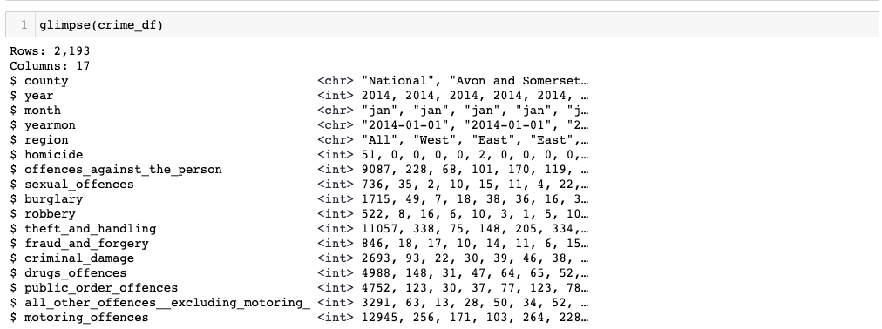

### 4.3.2. Unsuccessful Crime Dataset Glimpse

The dataset below shows a glimpse of rows, columns and few initial values for the Unsuccessful Crime dataset, which contains columns that represent the unsuccessful cases where the users didn’t either admit not found guilty of doing the respective crime.

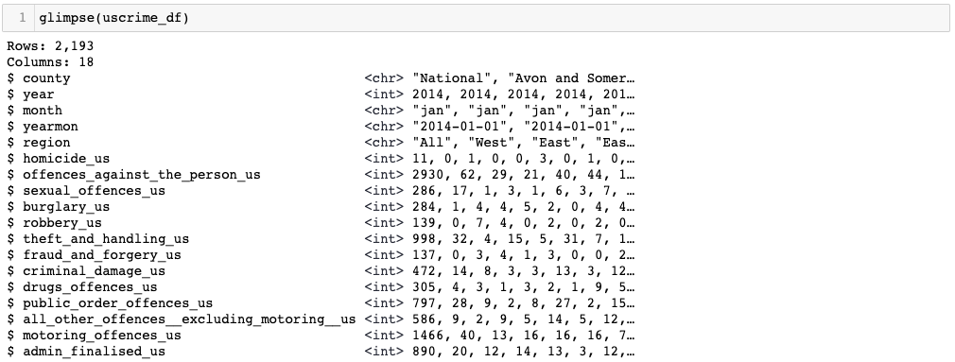

## 4.4. Code

The function splits the data frame into 2 dataframes based on their column names.

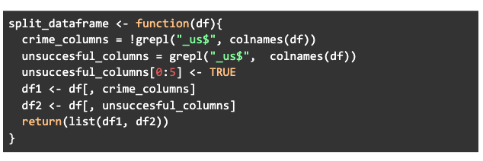

# 5. Descriptive Analytics

Descriptive analysis is a type of statistical analysis that involves summarizing and describing a set of data. This type of analysis is used to describe the main characteristics of a dataset, such as the central tendency (mean, median, mode), dispersion (range, variance, standard deviation), and distribution of the data. It also includes the use of visualizations such as histograms, box plots, and scatter plots to represent the data and its characteristics.

The goal of descriptive analysis is to provide a clear and concise summary of the data, highlighting important patterns and trends. It is used to understand the nature of the data and to identify any outliers or unusual observations. Descriptive analysis can also be used to identify any missing data or errors in the dataset.

Some examples of descriptive analysis include:

* Summarizing a dataset using measures of central tendency and dispersion
* Creating a frequency distribution table or a histogram to show the distribution of a variable
* Creating a box plot to show the distribution of a variable and identify outliers
* Creating a scatter plot to show the relationship between two variables.

Descriptive analysis is an essential step in data analysis as it helps to understand the data and identify patterns, which is crucial for any further statistical analysis or modeling. It is also the first step in Exploratory Data Analysis (EDA) which is an approach to analyzing data sets to summarize their main characteristics, often with visual methods.

## 5.1. Attributes Analysis

Attribute analysis is a process used to understand the characteristics of each variable or feature in a dataset. This can include identifying the data type, missing values, range, distribution, and any patterns or trends in the data.

As our dataset is divided into categories, we investigate each of their columns one by one below.

### 5.1.1. Crimes Dataset

#### 5.1.1.1. County

This column has all possible county values from england.

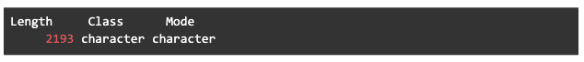

#### 5.1.1.2. Year

This column has 5 values because we are using a dataset from 5 years which are 2014, 2015, 2016, 2017 and 2018.

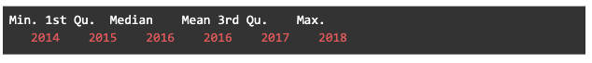

#### 5.1.1.3. Month

This column contains months ranging from January to December. 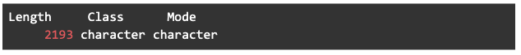

#### 

#### 5.1.1.4. Yearmon

This column contains combined values of year and month.

#### 5.1.1.5. Region

This column contains 5 possible values which are All, East, West, North and South.

#### 5.1.1.6. Homicide

It represents that the minimum value of the variable is 0, 25% of the values are below 0, the median value is 1, the mean value is 3.798, 75% of the values are below 3 and the maximum value is 131. It also indicates that the variable has some outliers as the max value is quite high as compared to the mean and the median.



#### 5.1.1.7. Offences_against_the_person

It represents that the minimum value of the variable is 29, 25% of the values are below 115, the median value is 179, the mean value is 454.9, 75% of the values are below 272 and the maximum value is 11741. It also indicates that the variable has some outliers as the max value is quite high as compared to the mean and the median.



#### 5.1.1.8. Sexual_offences

It represents that the minimum value of the variable is 0, 25% of the values are below 8, the median value is 15, the mean value is 43.78, 75% of the values are below 29 and the maximum value is 1179. It also indicates that the variable has some outliers as the max value is quite high as compared to the mean and the median.



#### 5.1.1.9. Burglary

It represents that the minimum value of the variable is 1, 25% of the values are below 14, the median value is 23, the mean value is 60.09, 75% of the values are below 38 and the maximum value is 1715. It also indicates that the variable has some outliers as the max value is quite high as compared to the mean and the median.



#### 5.1.1.10. Robbery

It represents that the minimum value of the variable is 0, 25% of the values are below 2, the median value is 5, the mean value is 19.33, 75% of the values are below 10 and the maximum value is 650. It also indicates that the variable has some outliers as the max value is quite high as compared to the mean and the median.



#### 5.1.1.11. Theft_and_handling

It represents that the minimum value of the variable is 13, 25% of the values are below 95, the median value is 147, the mean value is 373.1, 75% of the values are below 237 and the maximum value is 11057. It also indicates that the variable has some outliers as the max value is quite high as compared to the mean and the median.



#### 5.1.1.12. Fraud_and_forgery

It represents that the minimum value of the variable is 0, 25% of the values are below 8, the median value is 13, the mean value is 38.57, 75% of the values are below 21 and the maximum value is 1075. It also indicates that the variable has some outliers as the max value is quite high as compared to the mean and the median.



#### 5.1.1.13. Criminal_damage

It represents that the minimum value of the variable is 3, 25% of the values are below 25, the median value is 40, the mean value is 95.82, 75% of the values are below 59 and the maximum value is 2693. It also indicates that the variable has some outliers as the max value is quite high as compared to the mean and the median.



#### 5.1.1.14. Drugs_offences

It represents that the minimum value of the variable is 4, 25% of the values are below 38, the median value is 63, the mean value is 186.6, 75% of the values are below 100 and the maximum value is 4988. It also indicates that the variable has some outliers as the max value is quite high as compared to the mean and the median.



#### 5.1.1.15. Public_order_offences

It represents that the minimum value of the variable is 2, 25% of the values are below 39, the median value is 63, the mean value is 162.4, 75% of the values are below 100 and the maximum value is 4752. It also indicates that the variable has some outliers as the max value is quite high as compared to the mean and the median.



#### 5.1.1.16. All_other_offences__excluding_motoring_

It represents that the minimum value of the variable is 0, 25% of the values are below 9, the median value is 16, the mean value is 64.34, 75% of the values are below 35 and the maximum value is 3291. It also indicates that the variable has some outliers as the max value is quite high as compared to the mean and the median.



#### 5.1.1.17. Motoring_offences

It represents that the minimum value of the variable is 1, 25% of the values are below 95, the median value is 143, the mean value is 365.5, 75% of the values are below 216 and the maximum value is 12945. It also indicates that the variable has some outliers as the max value is quite high as compared to the mean and the median.



### 5.1.2. Unsuccessful Crimes Dataset

#### 5.1.2.1. County

This column has all possible county values from england.

| Length Class Mode   2193 character character |
| --- |

#### 5.1.2.2. Year

This column has 5 values because we are using a dataset from 5 years which are 2014, 2015, 2016, 2017 and 2018.

| Min. 1st Qu. Median Mean 3rd Qu. Max.   2014 2015 2016 2016 2017 2018 |
| --- |

#### 5.1.2.3. Month

This column contains months ranging from January to December.

| Length Class Mode   2193 character character |
| --- |

#### 5.1.2.4. Yearmon

This column contains combined values of year and month.

| Length Class Mode   2193 character character |
| --- |

#### 5.1.2.5. Region

This column contains 5 possible values which are All, East, West, North and South.

| Length Class Mode   2193 character character |
| --- |

#### 5.1.2.6. Homicide_us

It represents that the minimum value of the variable is 0, 25% of the values are below 0, the median value is 0, the mean value is 0.9138, 75% of the values are below 1 and the maximum value is 35. It also indicates that the variable has some outliers as the max value is quite high as compared to the mean and the median.

| Min. 1st Qu. Median Mean 3rd Qu. Max.   0.0000 0.0000 0.0000 0.9138 1.0000 35.0000 |
| --- |

#### 5.1.2.7. Offences_against_the_person_us

It represents that the minimum value of the variable is 5, 25% of the values are below 27, the median value is 46, the mean value is 135.4, 75% of the values are below 77 and the maximum value is 3568. It also indicates that the variable has some outliers as the max value is quite high as compared to the mean and the median.

| Min. 1st Qu. Median Mean 3rd Qu. Max.   5.0 27.0 46.0 135.4 77.0 3568.0 |
| --- |

#### 5.1.2.8. Sexual_offences_us

It represents that the minimum value of the variable is 0, 25% of the values are below 1, the median value is 4, the mean value is 16.19, 75% of the values are below 11 and the maximum value is 489. It also indicates that the variable has some outliers as the max value is quite high as compared to the mean and the median.

| Min. 1st Qu. Median Mean 3rd Qu. Max.   0.00 1.00 4.00 16.19 11.00 489.00 |
| --- |

#### 5.1.2.9. Burglary_us

It represents that the minimum value of the variable is 0, 25% of the values are below 1, the median value is 3, the mean value is 10.14, 75% of the values are below 6 and the maximum value is 317. It also indicates that the variable has some outliers as the max value is quite high as compared to the mean and the median.

| Min. 1st Qu. Median Mean 3rd Qu. Max.   0.00 1.00 3.00 10.14 6.00 317.00 |
| --- |

#### 5.1.2.10. Robbery_us

It represents that the minimum value of the variable is 0, 25% of the values are below 0, the median value is 1, the mean value is 5.16, 75% of the values are below 3 and the maximum value is 188. It also indicates that the variable has some outliers as the max value is quite high as compared to the mean and the median.

| Min. 1st Qu. Median Mean 3rd Qu. Max.   0.00 0.00 1.00 5.16 3.00 188.00 |
| --- |

#### 5.1.2.11. Theft_and_handling_us

It represents that the minimum value of the variable is 0, 25% of the values are below 6, the median value is 11, the mean value is 33.43, 75% of the values are below 19 and the maximum value is 1025. It also indicates that the variable has some outliers as the max value is quite high as compared to the mean and the median.

| Min. 1st Qu. Median Mean 3rd Qu. Max.   0.00 6.00 11.00 33.43 19.00 1025.00 |
| --- |

#### 5.1.2.12. Fraud_and_forgery_us

It represents that the minimum value of the variable is 0, 25% of the values are below 1, the median value is 2, the mean value is 6.232, 75% of the values are below 4 and the maximum value is 180. It also indicates that the variable has some outliers as the max value is quite high as compared to the mean and the median.

| Min. 1st Qu. Median Mean 3rd Qu. Max.   0.000 1.000 2.000 6.232 4.000 180.000 |
| --- |

#### 5.1.2.13. Criminal_damage_us

It represents that the minimum value of the variable is 0, 25% of the values are below 3, the median value is 6, the mean value is 16.43, 75% of the values are below 10 and the maximum value is 491. It also indicates that the variable has some outliers as the max value is quite high as compared to the mean and the median.

| Min. 1st Qu. Median Mean 3rd Qu. Max.   0.00 3.00 6.00 16.43 10.00 491.00 |
| --- |

#### 5.1.2.14. Drugs_offences_us

It represents that the minimum value of the variable is 0, 25% of the values are below 2, the median value is 4, the mean value is 12.57, 75% of the values are below 7 and the maximum value is 346. It also indicates that the variable has some outliers as the max value is quite high as compared to the mean and the median.

| Min. 1st Qu. Median Mean 3rd Qu. Max.   0.00 2.00 4.00 12.57 7.00 346.00 |
| --- |

#### 5.1.2.15. Public_order_offences_us

It represents that the minimum value of the variable is 0, 25% of the values are below 5, the median value is 9, the mean value is 28.45, 75% of the values are below 16 and the maximum value is 801. It also indicates that the variable has some outliers as the max value is quite high as compared to the mean and the median.

| Min. 1st Qu. Median Mean 3rd Qu. Max.   0.00 5.00 9.00 28.45 16.00 801.00 |
| --- |

#### 5.1.2.16. All_other_offences__excluding_motoring__us

It represents that the minimum value of the variable is 0, 25% of the values are below 1, the median value is 3, the mean value is 11.91, 75% of the values are below 7 and the maximum value is 603. It also indicates that the variable has some outliers as the max value is quite high as compared to the mean and the median.

| Min. 1st Qu. Median Mean 3rd Qu. Max.   0.00 1.00 3.00 11.91 7.00 603.00 |
| --- |

#### 5.1.2.17. Motoring_offences_us

It represents that the minimum value of the variable is 0, 25% of the values are below 11, the median value is 20, the mean value is 60.95, 75% of the values are below 34 and the maximum value is 1725. It also indicates that the variable has some outliers as the max value is quite high as compared to the mean and the median.

| Min. 1st Qu. Median Mean 3rd Qu. Max.   0.00 11.00 20.00 60.95 34.00 1725.00 |
| --- |

#### 5.1.2.18. Admin_finalised_us

It represents that the minimum value of the variable is 0, 25% of the values are below 7, the median value is 12, the mean value is 38.82, 75% of the values are below 21 and the maximum value is 1051. It also indicates that the variable has some outliers as the max value is quite high as compared to the mean and the median.

| Min. 1st Qu. Median Mean 3rd Qu. Max.   0.00 7.00 12.00 38.82 21.00 1051.00 |
| --- |

## 5.2. Analysis dependent on Regions

In this section of analysis, we try to understand the relations between crime times and their occurrence in various regions of the englands using graph visualization and statistical analysis.

### 5.2.1. Region & All Types

We consider both datasets, i.e. crimes and un-successful crimes datasets and visualize their occurrence grouped by crime types in different regions of england.

#### 5.2.1.1. Crimes

The graph below considered the crime cases and shows that offenses below the person are the highest in every region of england especially North side. Robbery is the second highest and it maintains the trend across all regions of England and topping it in the North. The third highest is Motoring within all the regions and all other crimes follow in a similar way. Generally, North has the highest peaks of crimes and East can be observed to be the Lowest.

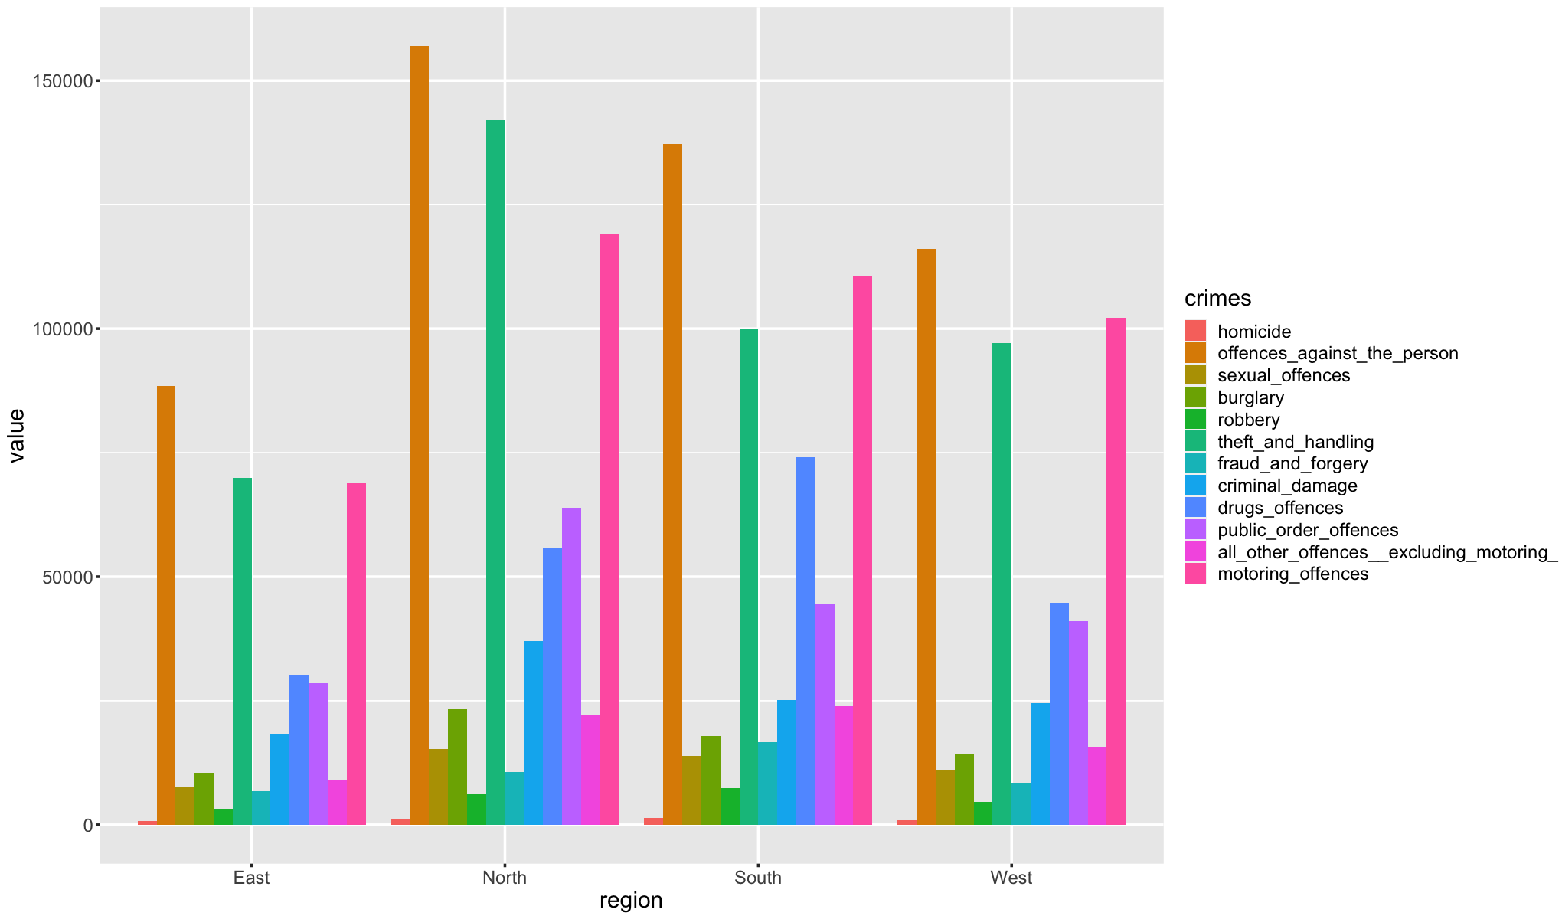

#### 5.2.1.2. Unsuccessful Crimes

The graph below considers the unsuccessful cases and shows that unsuccessful offenses below the person are the highest in every region of England, especially the South side. Unsuccessful Motoring Offences is the second highest and it maintains the trend across all regions of England and topping it in the South. The third highest is Unsuccessful Admin Finalized within all the regions and all other crimes follow in a similar way. Generally, South has the highest peaks of unsuccessful cases and East can be observed to be the Lowest.

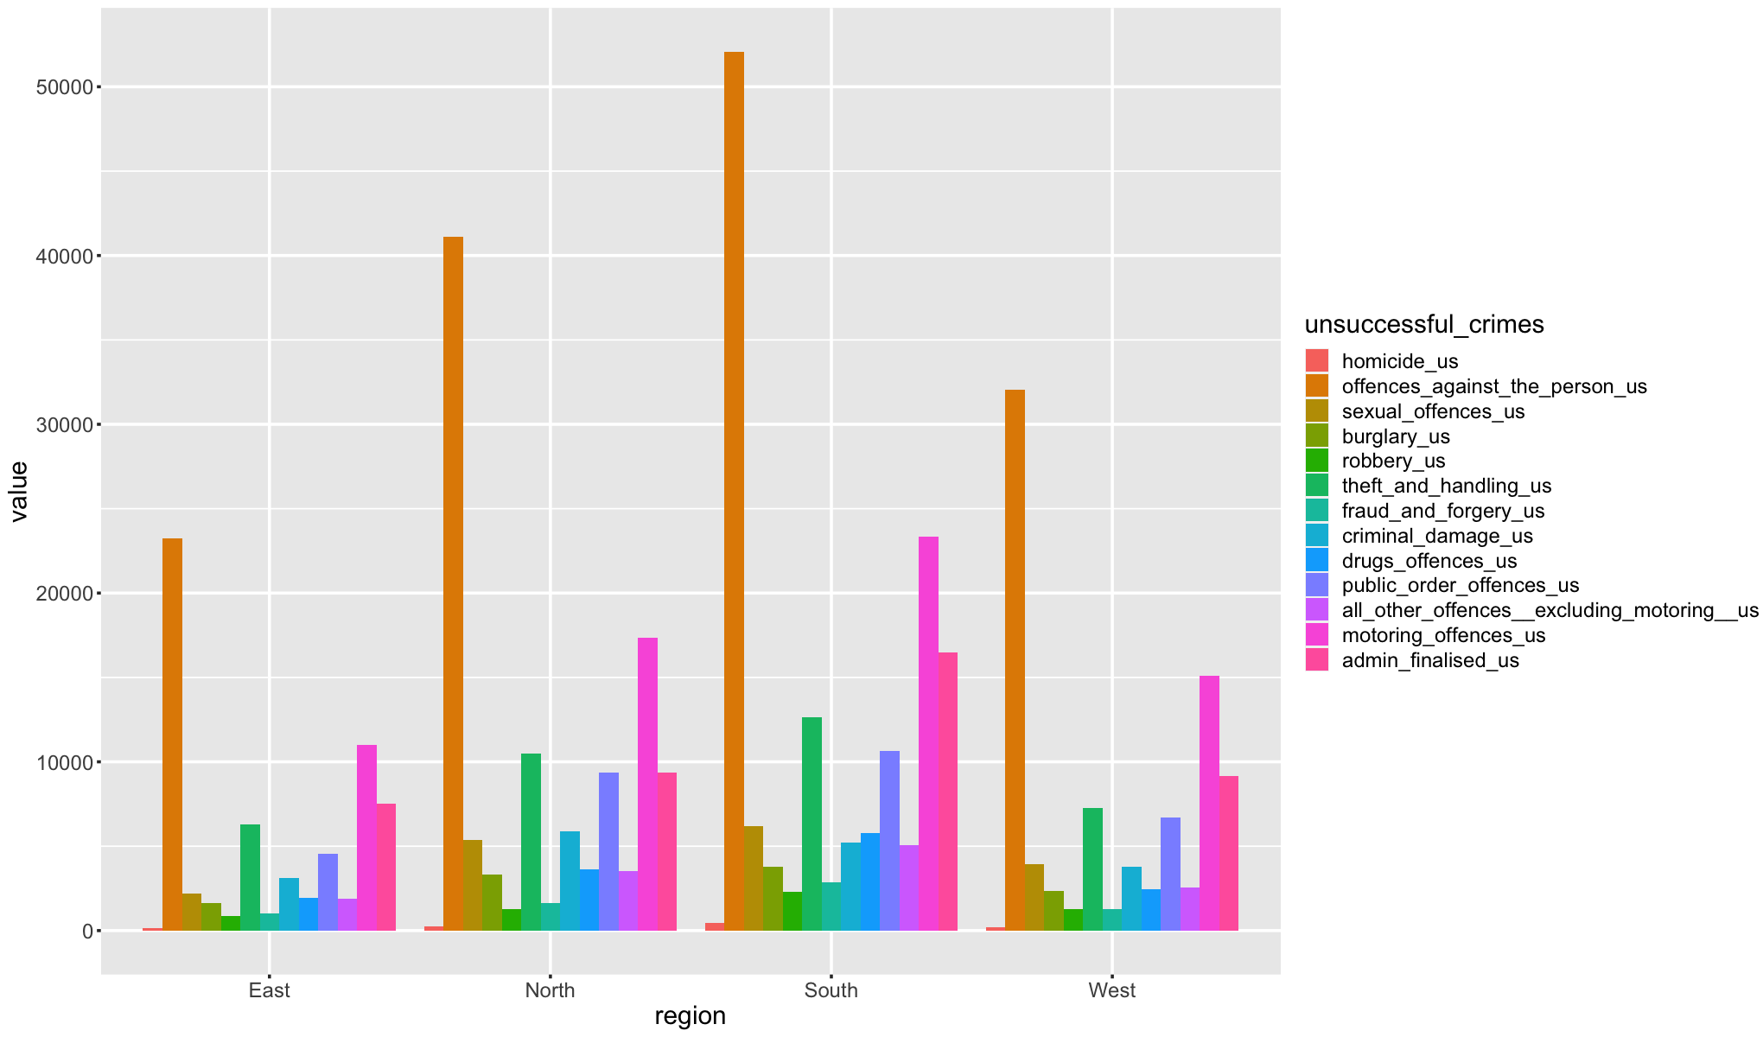

#### 5.2.1.3. Code

This function takes a dataframe as input and groups it by the "region" column. It removes the first four columns, removes any rows where the "region" column is "All" and then groups the remaining data by the "region" column. Then it applies the sum function to all columns in the dataframe and return the summarized dataframe.

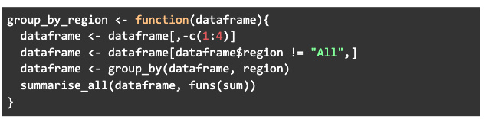

### 5.2.2. Region & Sum of All

In this section, we consider and compare the total count of crimes and unsuccessful cases in the various of regions of England.

#### 5.2.2.1. Crimes

There have been a total 2048554 crimes across all regions of England where North has the highest number, i.e. 653326 while East has the lowest, i.e. 342048. Whereas West and South are 2nd and 3rd with 572792 and 480388 crimes respectively.

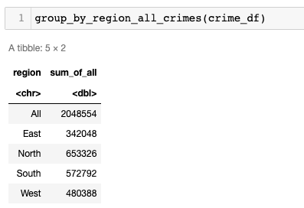

#### 5.2.2.2. Unsuccessful Crimes

There have been a total 412978 unsuccessful cases across all regions of England where South has the highest number, i.e. 146850 while East has the lowest, i.e. 65468. Whereas North and West are 2nd and 3rd with 112594 and 88066 unsuccessful cases respectively.

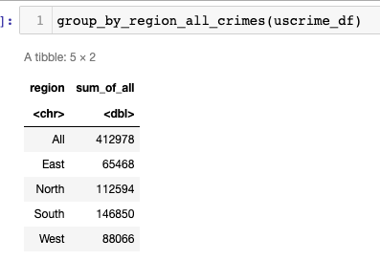

#### 5.2.2.3. Code

This function takes a dataframe as input, removes the first four columns, creates a new column called "sum_of_all" that contains the sum of all numeric columns, keeps only the "region" and "sum_of_all" columns and then groups the data by the "region" column. It then applies the sum function to all columns in the dataframe and return the summarized dataframe.

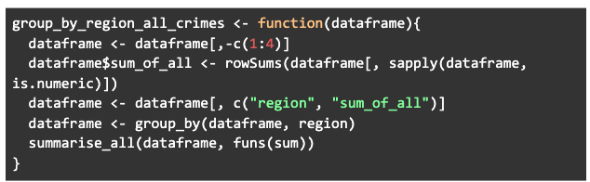

## 5.3. Analysis dependent on Years & Months

In this section of analysis, we try to understand the relations between successful and unsuccessful crime occurrences in various counties of England with respect to years and months using graph visualization.

### 5.3.1. 2014

#### 5.3.1.1. Crimes

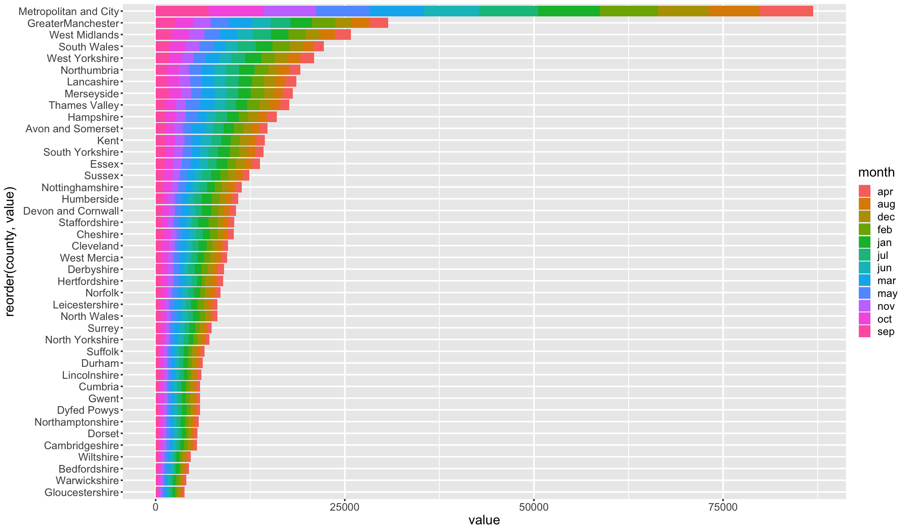

#### 5.3.1.2. Unsuccessful Crimes

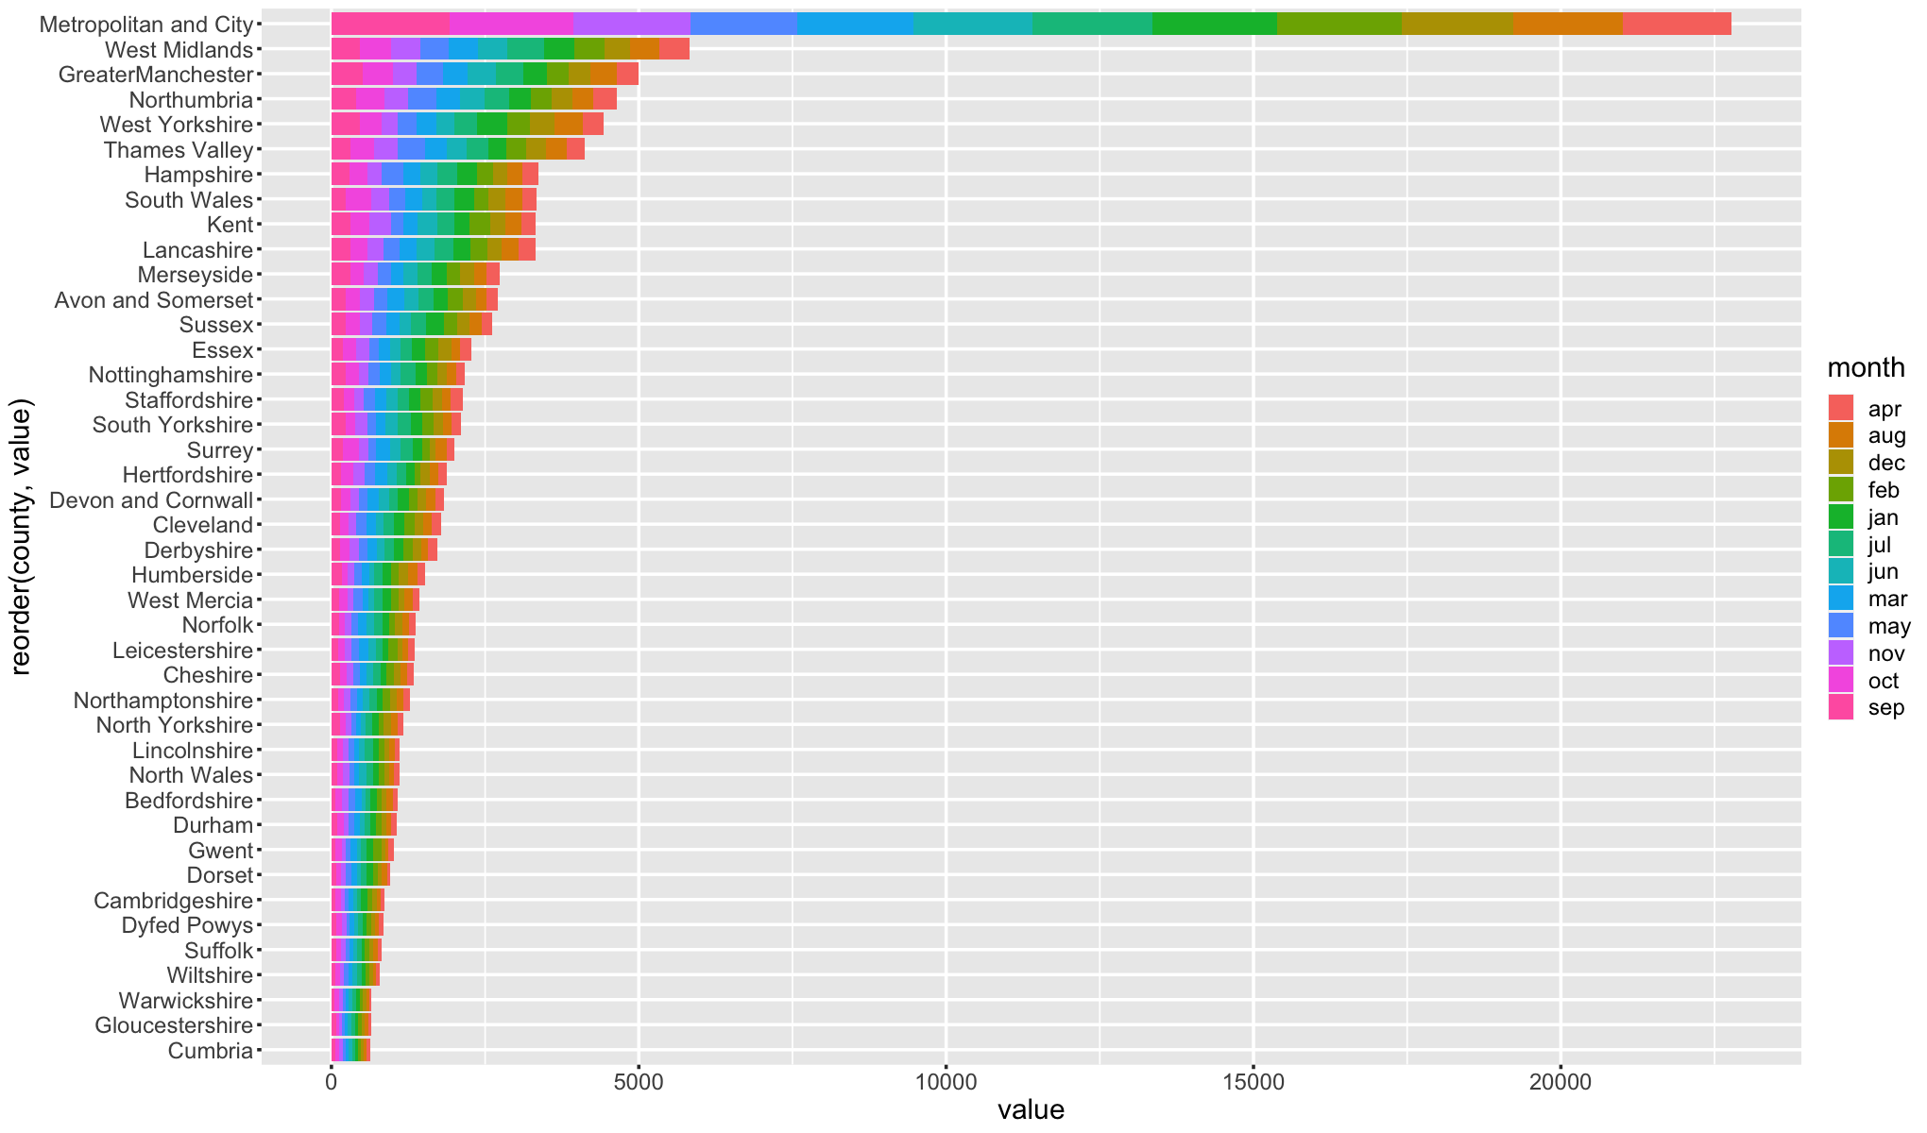

### 5.3.2. 2015

#### 5.3.2.1. Crimes

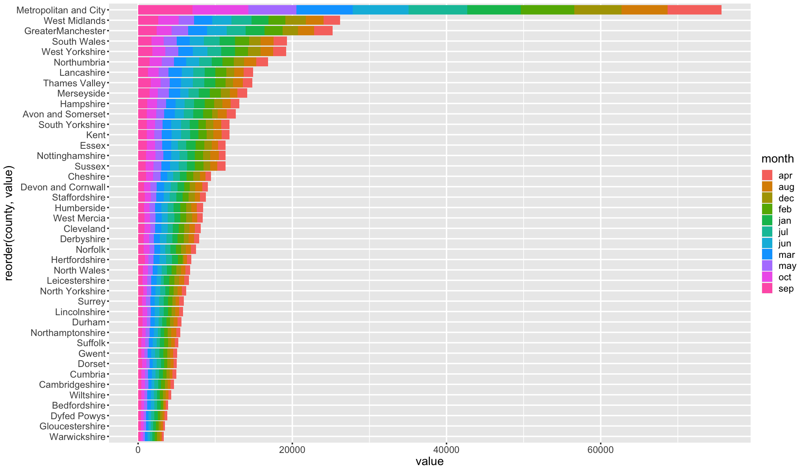

#### 5.3.2.2. Unsuccessful Crimes

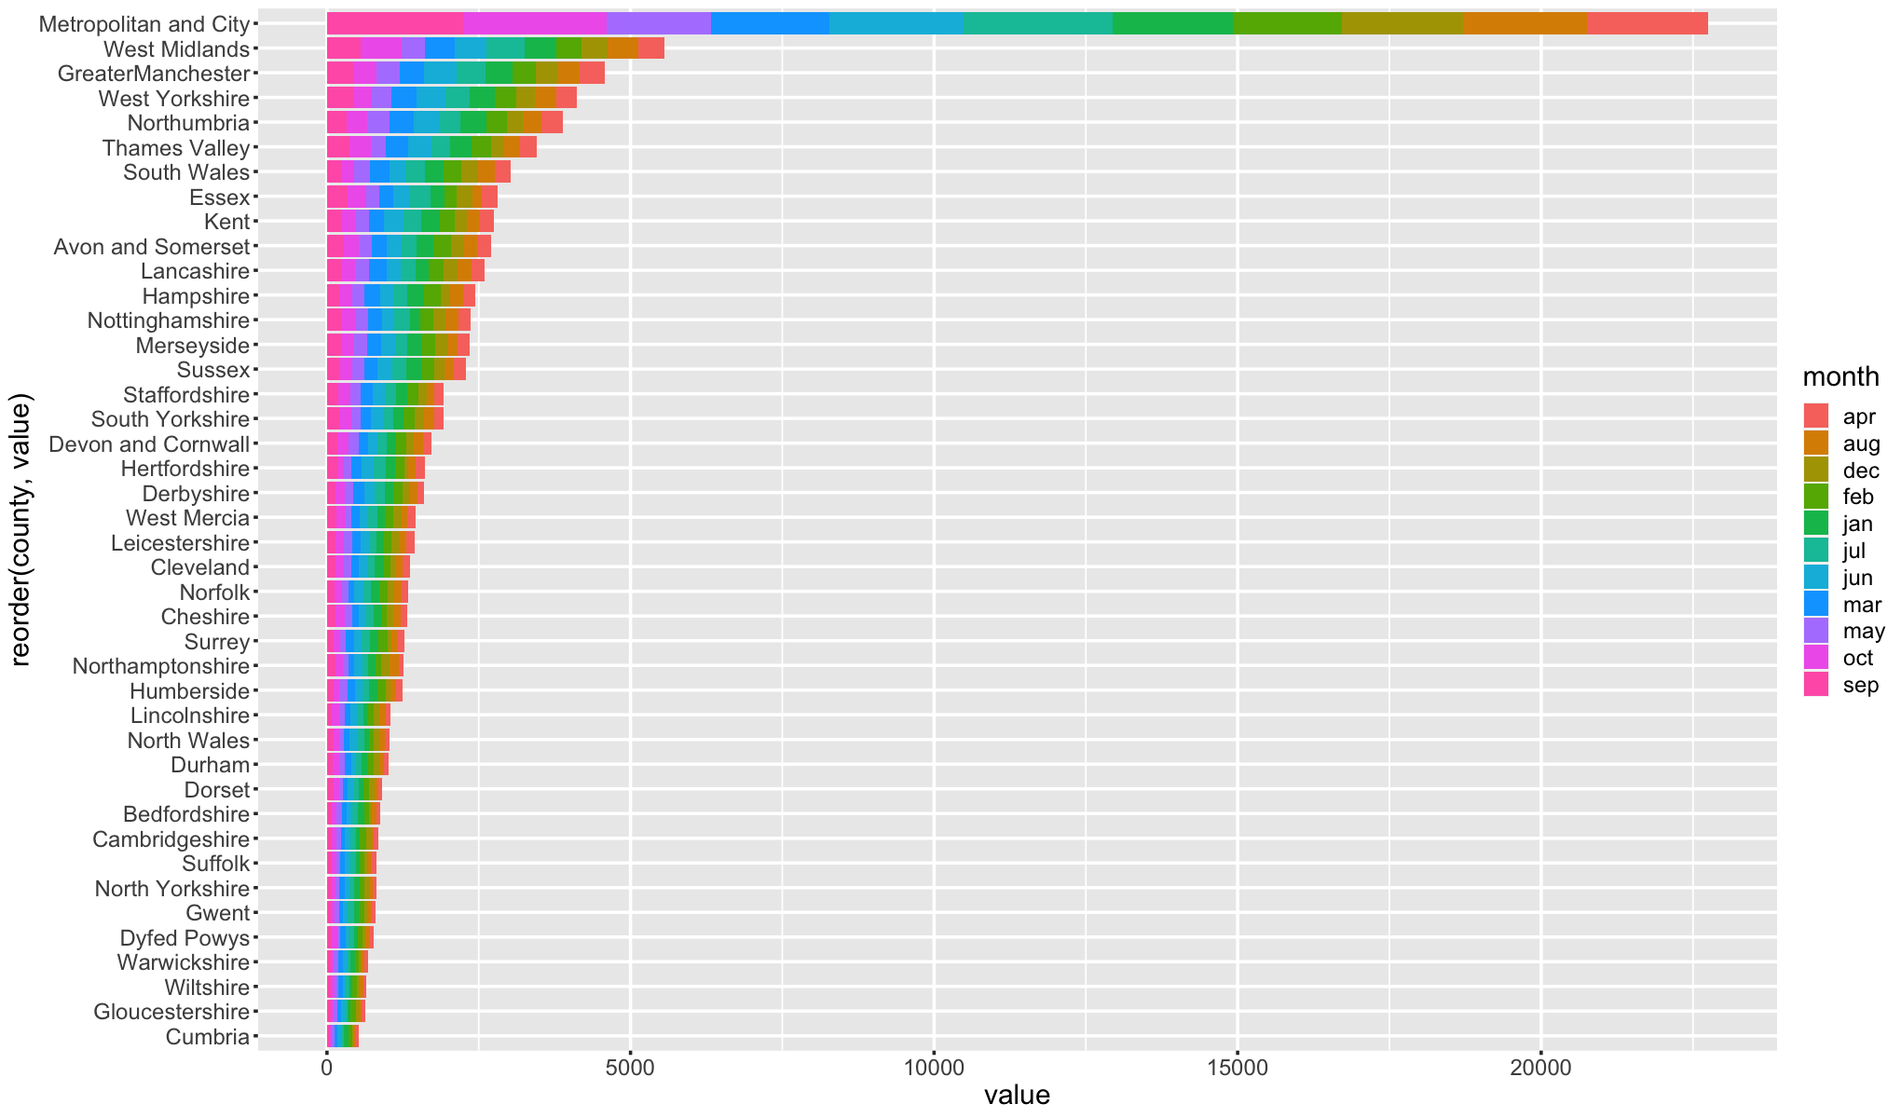

### 5.3.3. 2016

#### 5.3.3.1. Crimes

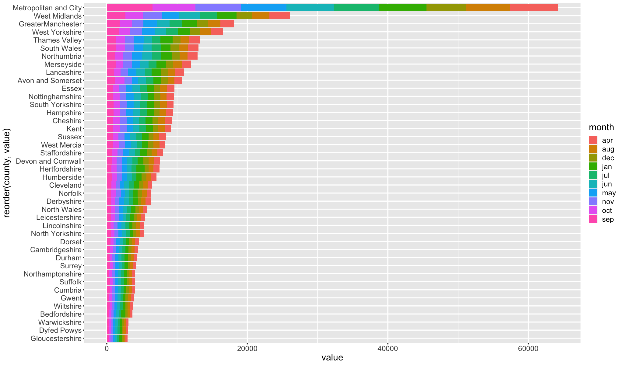

#### 5.3.3.2. Unsuccessful Crimes

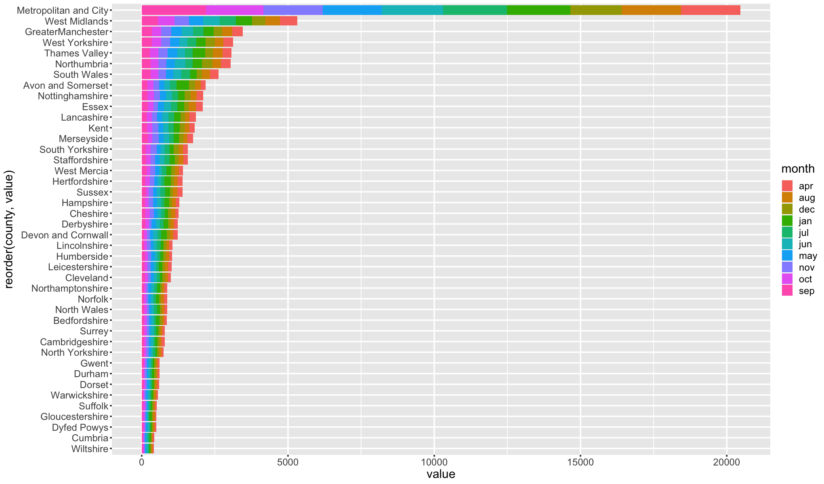

### 5.3.4. 2017

#### 5.3.4.1. Crimes

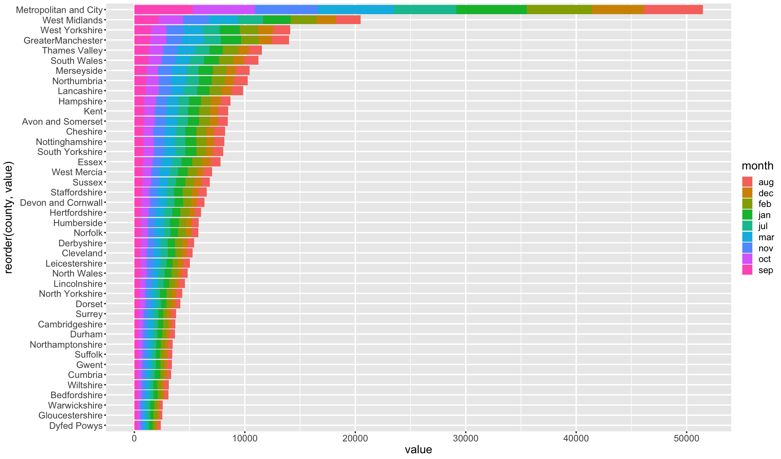

#### 5.3.4.2. Unsuccessful Crimes

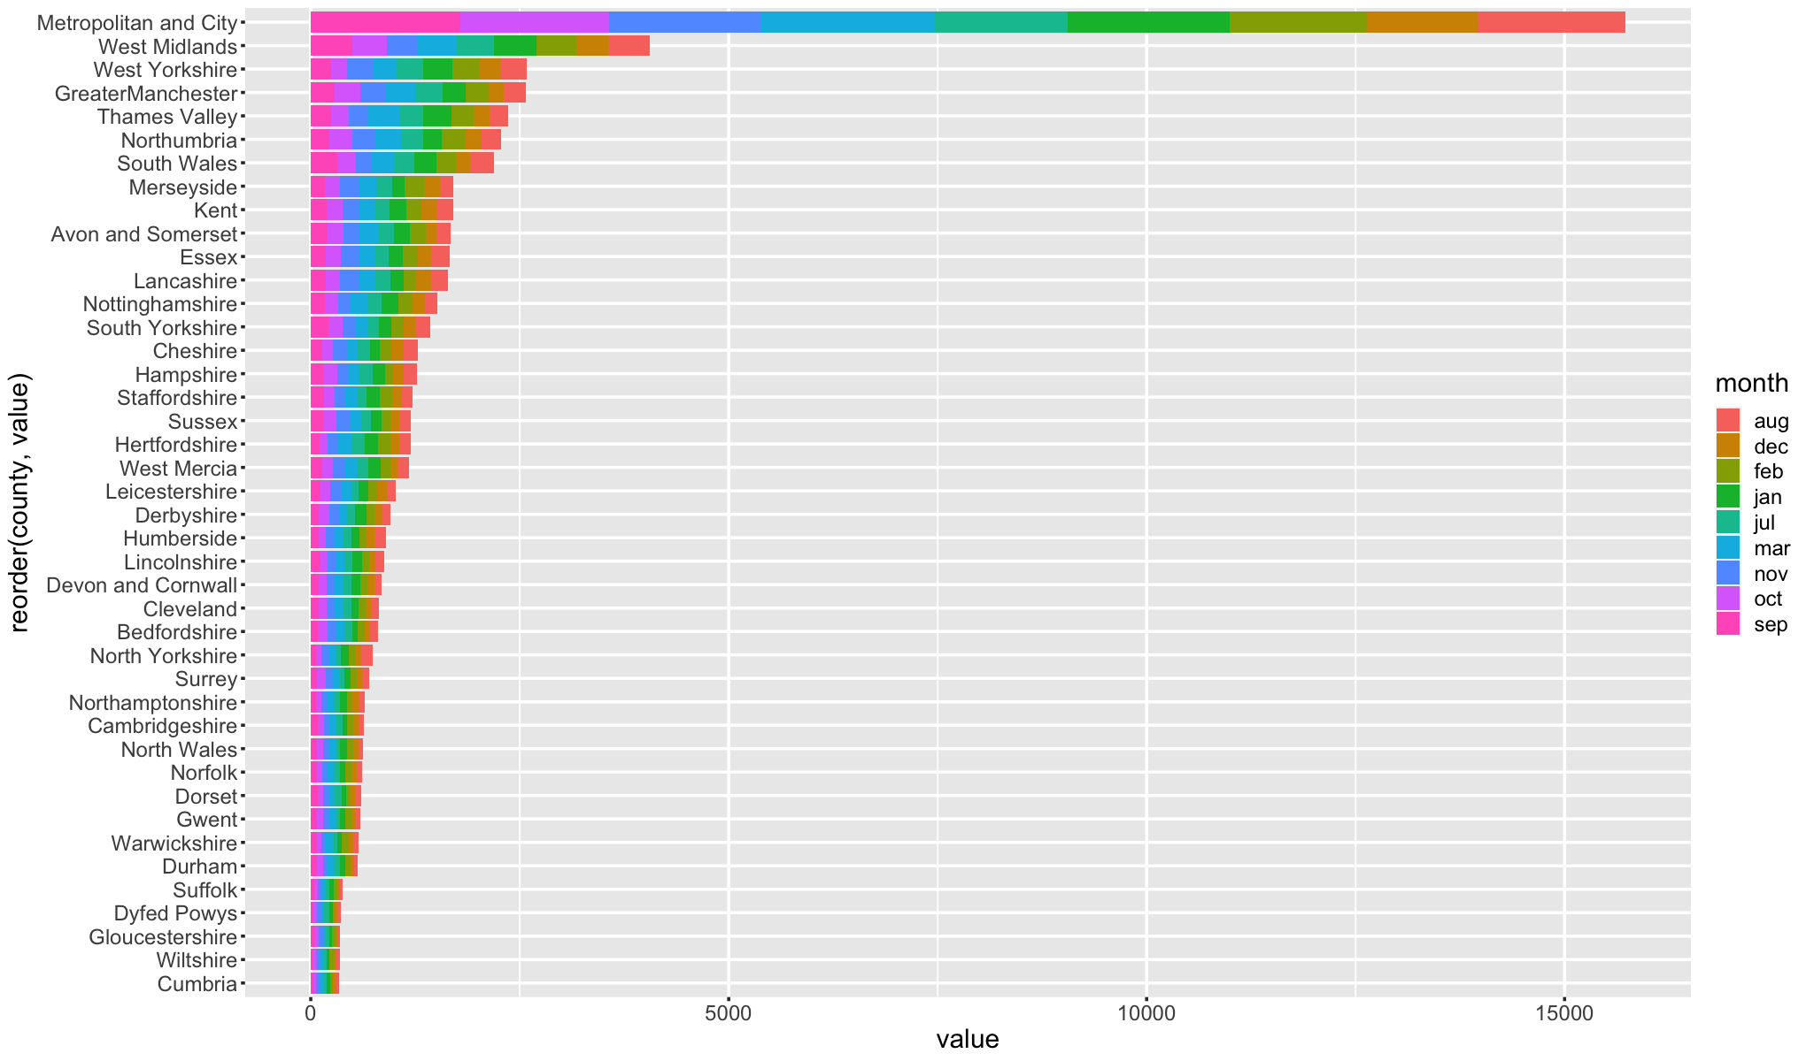

### 5.3.5. 2018

#### 5.3.5.1. Crimes

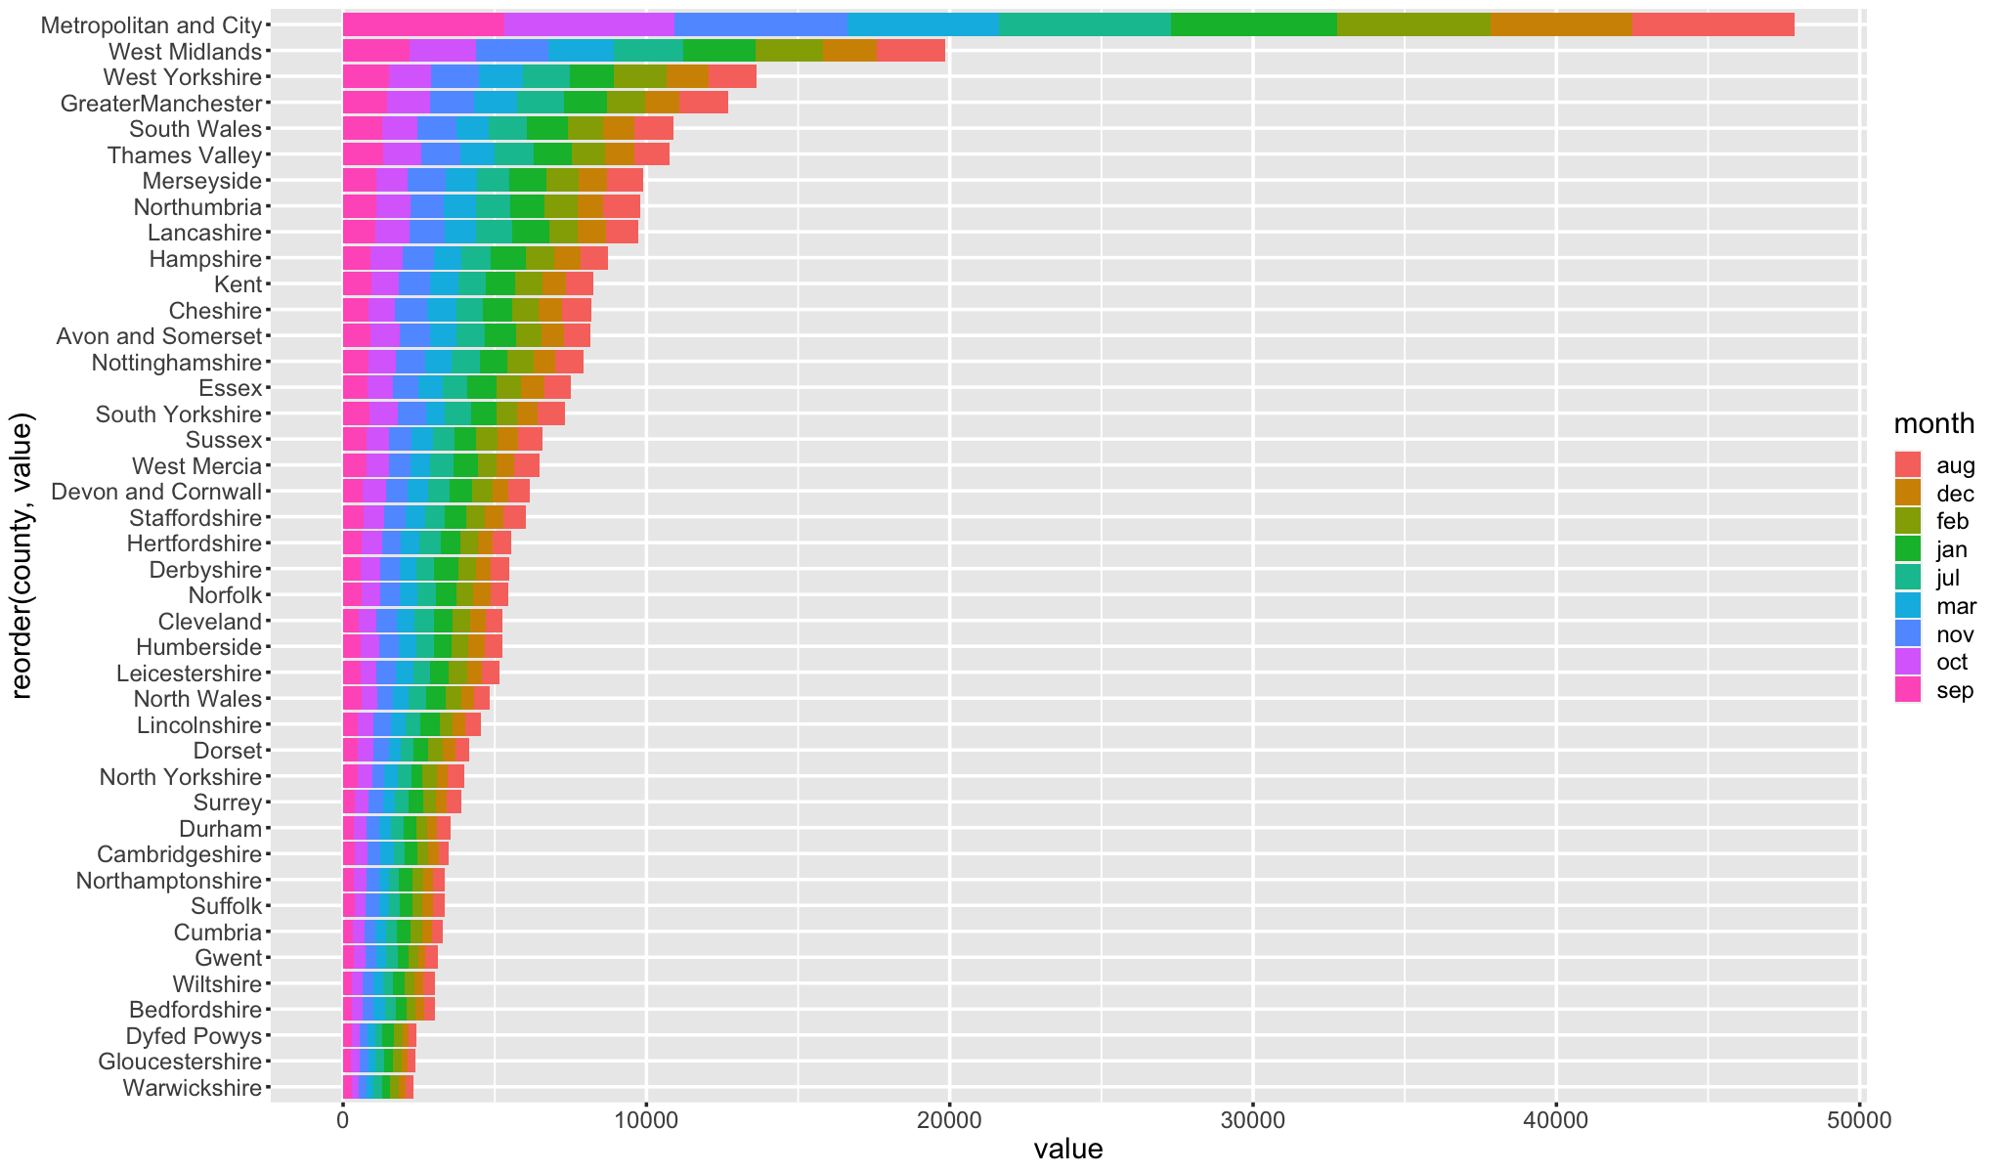

#### 5.3.5.2. Unsuccessful Crimes

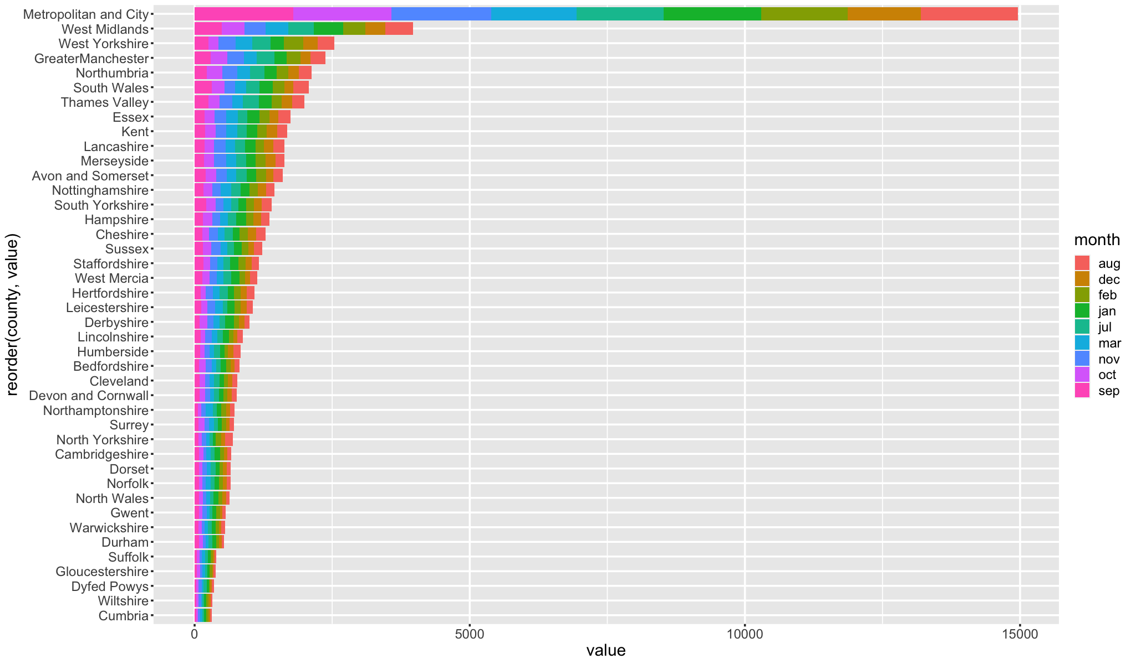

### 5.3.6. Code

#### 5.3.6.1. Group_by_year_month

This function takes a dataframe and year as inputs and groups the data by county and month. It filters the dataframe to only include rows where the year column matches the input year, removes any rows where the county column is "National", removes the year, yearmon and region columns, creates a new column called "sum_of_all" that contains the sum of all numeric columns, keeps only the "county", "month" and "sum_of_all" columns, groups the data by the "county" and "month" columns and then applies the sum function to all columns in the dataframe and return the summarized dataframe.

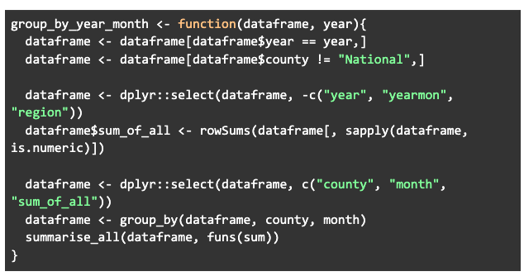

#### 5.3.6.2. Plot_graph

This function takes a dataframe and year as inputs and plots a stacked bar chart using ggplot2 library. It first applies the function group_by_year_month to the input dataframe and year to obtain a dataframe grouped by county and month. Then it uses the melt function to reshape the dataframe so that each county and month is represented in a single row with columns for the crimes and values. It then plots the data using ggplot2 library with the x-axis being the 'value' column, the y-axis being the 'county' column reordered by 'value' and the fill aesthetic being the 'month' column. Additionally, it changes the default plot size, text size, and line width.

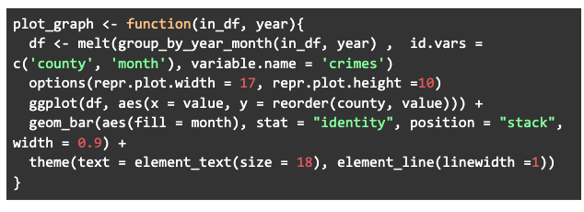

## 5.4. Analysis between Crime Types

In this section of analysis, we try to understand the correlation and covariance between successful and unsuccessful crime.

### 5.4.1. Correlation

Correlation is a statistical measure that describes the relationship between two or more variables. It is a normalized version of covariance, which means that it scales the relationship between variables in terms of a value between -1 and 1. A value of 1 indicates a perfect positive correlation, meaning that as one variable increases, the other also increases, and vice versa. A value of -1 indicates a perfect negative correlation, meaning that as one variable increases, the other decreases, and vice versa. A value of 0 indicates no correlation, meaning that there is no relationship between the variables.

For example, in the context of crime, a positive correlation between the number of burglaries and the number of thefts would indicate that an increase in burglaries is associated with an increase in thefts, and vice versa. A negative correlation between the number of burglaries and the number of drug offenses, on the other hand, would indicate that an increase in burglaries is associated with a decrease in drug offenses, and vice versa.

Correlation is typically represented as a numerical value, such as a Pearson correlation coefficient, and can be used in conjunction with other statistical measures, such as regression analysis, to better understand the relationship between variables.

It's worth mentioning that correlation does not indicate causality, it just indicates that two variables are related and in which direction the relationship is.

#### 5.4.1.1. Crimes

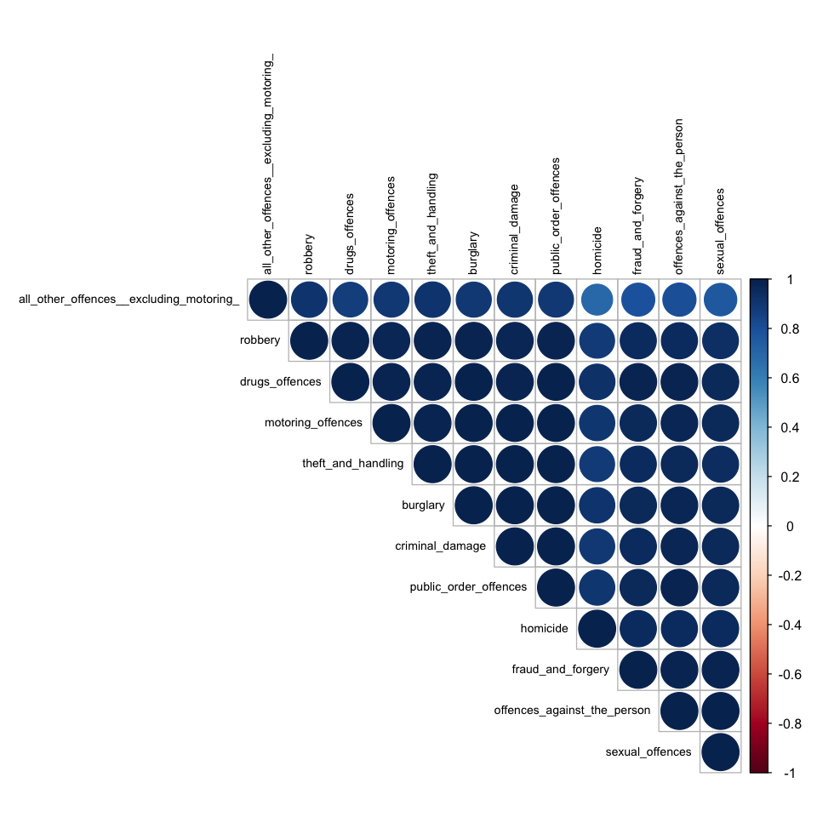

This is a correlation matrix, which shows the correlation coefficients between different types of crimes. The matrix shows the correlation between each type of crime with every other type of crime. Each cell in the matrix represents the correlation coefficient between the two types of crime corresponding to the row and column of that cell. The correlation coefficient ranges between -1 and 1, where a value of 1 indicates a perfect positive correlation, a value of -1 indicates a perfect negative correlation, and a value of 0 indicates no correlation.

The correlation matrix can be used to understand the relationships between different types of crime. For example, it can be seen that homicide has a high correlation with offences against the person (0.95), sexual offences (0.96), burglary (0.91) and robbery (0.89) which suggest that those crimes tend to happen together.

On the other hand, it can be seen that the lowest correlation is between motoring offences and other crimes. For example, the correlation between motoring offences and homicide is 0.91, between motoring offences and offences against the person is 0.98, and between motoring offences and sexual offences is 0.96. These values are lower than the correlation between other types of crimes, such as homicide, offences against the person and sexual offences, which have a correlation of 0.95, 0.99 and 0.99 respectively.

This suggests that motoring offences are not as closely related to other types of crime as other types of crime are related to each other. This might indicate that people who commit motoring offences are different from people who commit other types of crimes, and that different intervention and prevention strategies may be needed to address these types of crime.

#### 5.4.1.2. Unsuccessful Crimes

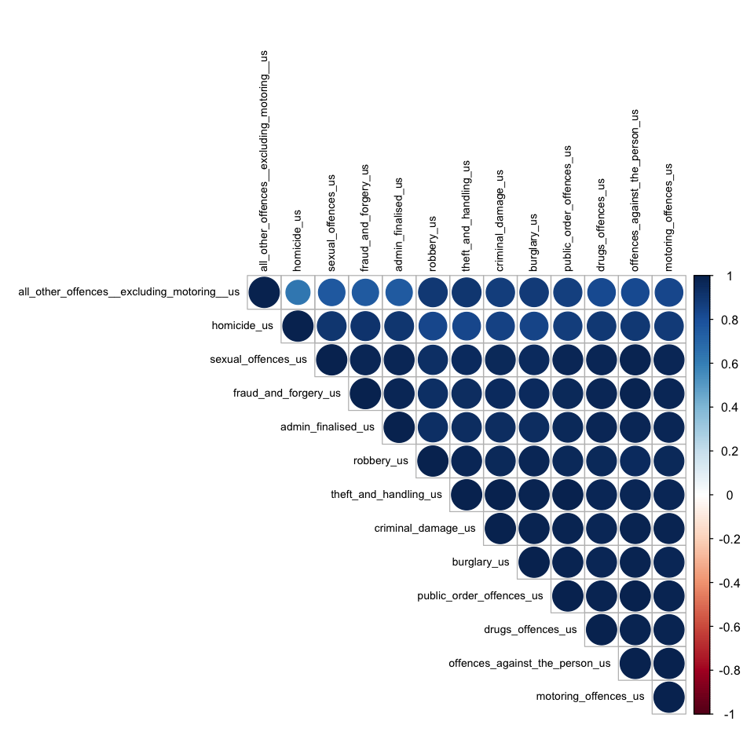

The correlation matrix above represents the correlation between different types of unsuccessful crimes. The values in the matrix range from -1 to 1, where 1 represents a perfect positive correlation, -1 represents a perfect negative correlation, and 0 represents no correlation. The correlation coefficient of a pair of variables is a measure of the strength and direction of the linear relationship between the two variables.

From the correlation matrix, we can see that some unsuccessful crimes have a higher correlation than others. For example, unsuccessful homicide has a high positive correlation with unsuccessful offences against the person (0.89), unsuccessful sexual offences (0.90), and unsuccessful burglary (0.85). These crimes are likely to occur together or be related in some way. On the other hand, crimes such as unsuccessful homicide and unsuccessful motoring offences have a lower correlation (0.91) indicating that they are less likely to occur together.

Additionally, from the matrix we can observe that unsuccessful crimes that have low correlation with other types of unsuccessful crimes, for example homicide_us and motoring_offences_us have a correlation of 0.91 which is lower than other crimes and this indicates that these unsuccessful crimes might be less related or less likely to happen together.

#### 5.4.1.3. Code

This function takes a dataframe as input and plots a correlation matrix using the corrplot library. It first selects only the numeric columns of the dataframe, then it calculates the correlation matrix using the cor() function. It then changes the default plot size, and it plots the correlation matrix using the corrplot() function. This function plots the correlation matrix and returns the correlation matrix as output. The function corrplot() uses the "upper" type, "hclust" order, and other parameters like cex and color to customize the appearance of the matrix.

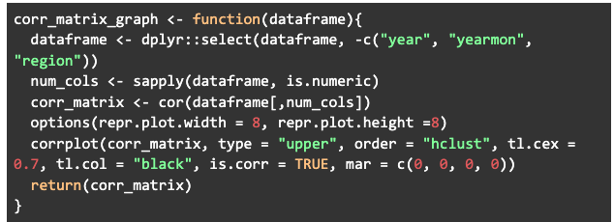

### 5.4.2. Covariance

Covariance is a statistical measure that describes the relationship between two or more variables. It measures the degree to which two variables change together, and it can indicate whether the variables have a positive or negative relationship. A positive covariance means that the variables tend to increase or decrease together, while a negative covariance means that the variables tend to move in opposite directions.

For example, in the context of crime, a positive covariance between the number of burglaries and the number of thefts would indicate that an increase in burglaries is associated with an increase in thefts, and vice versa. A negative covariance between the number of burglaries and the number of drug offenses, on the other hand, would indicate that an increase in burglaries is associated with a decrease in drug offenses, and vice versa.

Covariance is typically represented as a numerical value, and it can be used in conjunction with correlation to better understand the relationship between variables. Correlation is a normalized version of covariance, allowing to compare the strength of the relationship independent of the scale of the variables.

It's worth mentioning that covariance alone does not indicate causality, it just indicates that two variables are related, but it doesn't tell us in which direction the relationship is.

#### 5.4.2.1. Crimes

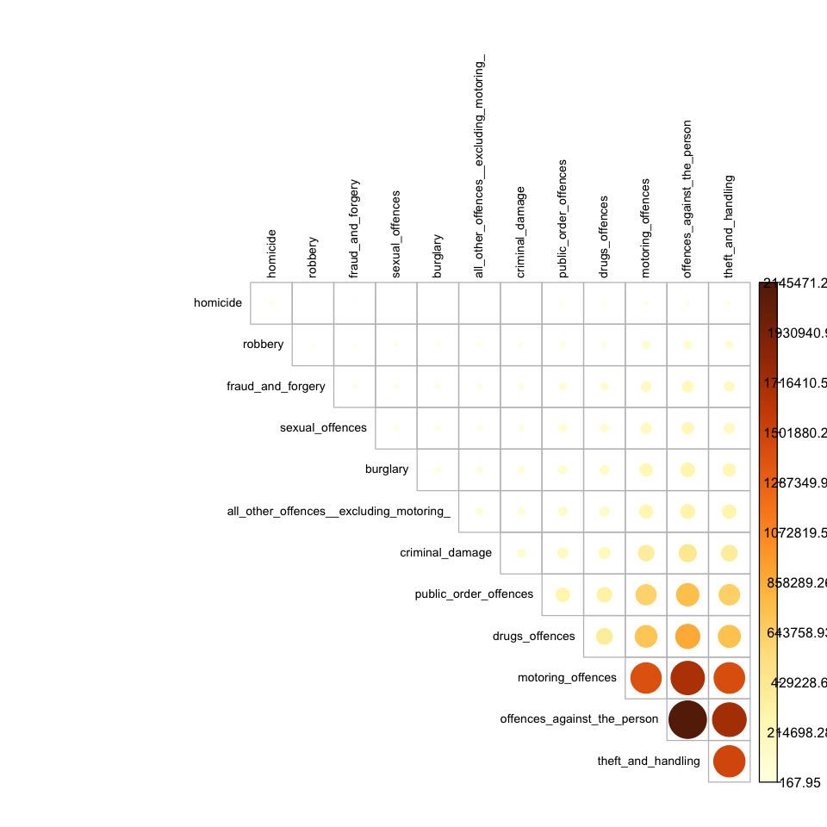

The covariance matrix for crimes is a matrix that shows the relationship between different types of crimes. Each cell in the matrix shows the covariance between two types of crimes. The covariance between two types of crimes is a measure of how much the two types of crimes vary together. A positive covariance indicates that the two types of crimes tend to increase or decrease together, while a negative covariance indicates that the two types of crimes tend to move in opposite directions. The larger the covariance, the stronger the relationship between the two types of crimes.

The top two covariance values in the matrix above are the values for "offences_against_the_person" and "homicide" (2145471.23) and "sexual_offences" and "offences_against_the_person" (206691.68). A high covariance value indicates that there is a strong linear relationship between the two variables. In this case, it suggests that there is a strong linear relationship between "offences_against_the_person" and "homicide" and between "sexual_offences" and "offences_against_the_person".

The lowest two covariance values in the matrix above are the values for "homicide" and "motoring_offences" (13975.66) and "all_other_offences__excluding_motoring_" and "motoring_offences" (263138.87). A low covariance value indicates that there is a weak linear relationship between the two variables. In this case, it suggests that there is a weak linear relationship between "homicide" and "motoring_offences" and between "all_other_offences__excluding_motoring_" and "motoring_offences".

#### 5.4.2.2. Unsuccessful Crimes

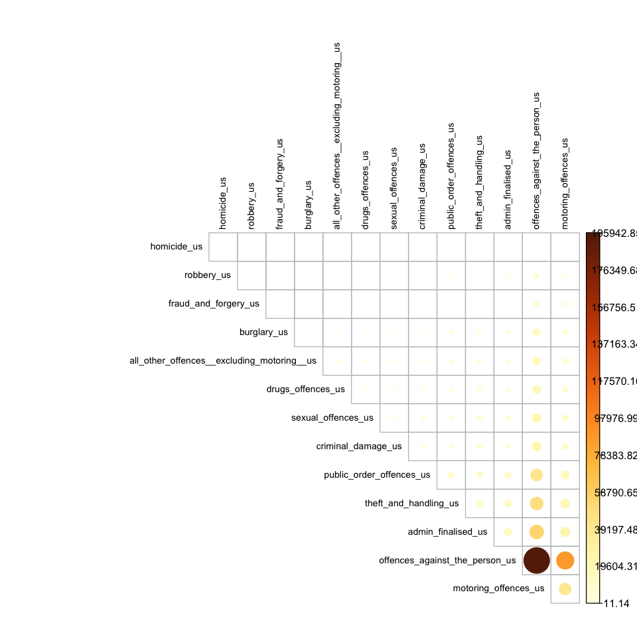

The covariance matrix for unsuccessful crimes is a matrix that shows the relationship between different types of unsuccessful crimes. Each cell in the matrix shows the covariance between two types of crimes. The covariance between two types of crimes is a measure of how much the two types of crimes vary together. A positive covariance indicates that the two types of crimes tend to increase or decrease together, while a negative covariance indicates that the two types of crimes tend to move in opposite directions. The larger the covariance, the stronger the relationship between the two types of crimes.

The highest covariance in the matrix for unsuccessful crimes is between offences against the person and sexual offences, with a covariance value of 195942.85. This suggests that there is a strong positive relationship between these two types of crime, such that when the rate of offences against the person increases, the rate of sexual offences also increases, and vice versa.

The second highest covariance is between offences against the person and burglary, with a covariance value of 14800.29. This indicates that there is also a positive relationship between these two types of crime, but not as strong as the relationship between offences against the person and sexual offences.

On the other hand, the lowest covariance in the matrix is between homicide and motoring offences, with a covariance value of 102.27. This suggests that there is a very weak relationship or no relationship between these two types of crime. Similarly, the second lowest covariance is between homicide and all other offences (excluding motoring) with a covariance value of 273.88, which also suggests a weak relationship between these two types of crime.

#### 5.4.2.3. Code

This function takes a dataframe as input and plots a covariance matrix using the corrplot library. It first selects only the numeric columns of the dataframe, then it calculates the covariance matrix using the cov() function. It then changes the default plot size, and it plots the covariance matrix using the corrplot() function with the is.corr parameter set to false. This function plots the covariance matrix and returns the covariance matrix as output. The function corrplot() uses the "upper" type, "hclust" order, and other parameters like cex and color to customize the appearance of the matrix. The difference with previous function is that it uses the cov() function to calculate the covariance matrix instead of correlation matrix which is the case in 'corr_matrix_graph' function.

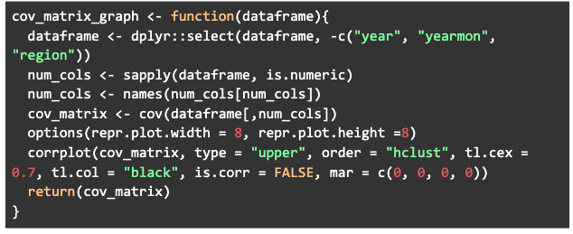

## 5.5. Trend Analysis for Successful & Unsuccessful Crimes

In this section of analysis, we try to understand the trend between successful and unsuccessful crime.

### 5.5.1. Visualization

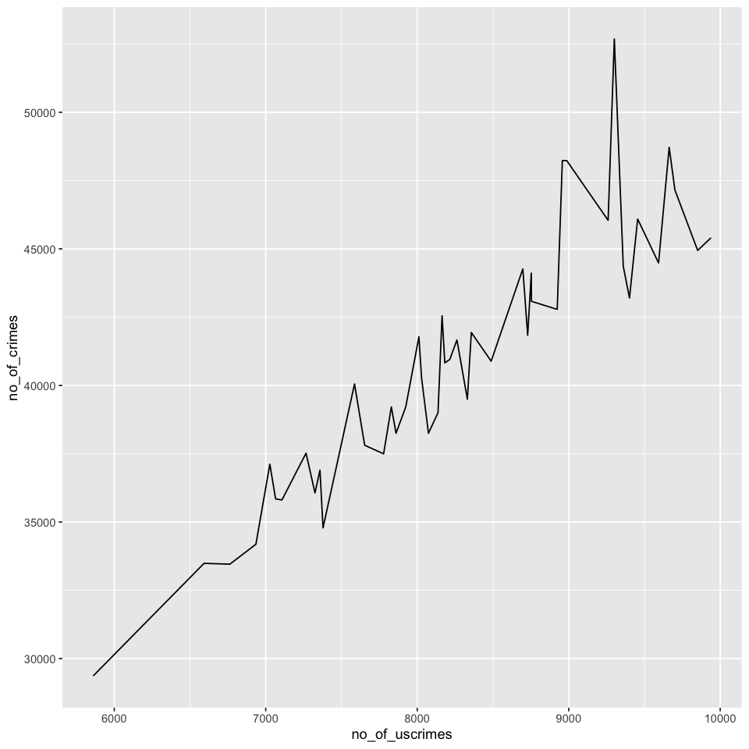

The visualization above of successful and unsuccessful crimes show that the number of cases for un-successful crimes increase with the increase in number of crimes.

The pros of crime cases and unsuccessful crime cases increasing together could include the following:

* It may indicate that law enforcement efforts are effective in detecting and addressing criminal activity.
* It may also suggest that the criminal justice system is working well in identifying and pursuing cases that are unlikely to result in successful convictions.

However, there are also several cons to consider:

* An increase in unsuccessful crime cases could indicate a lack of resources or a backlog in the criminal justice system, potentially leading to delays and inefficiencies in the process.
* It may also suggest that the police is not able to effectively investigate and prosecute crimes.
* An increase in crime and unsuccessful crime cases together may also lead to a strain on the criminal justice system, and could lead to a decrease in public trust and confidence in the system.
* It could also lead to the overburdening of the criminal justice system and lead to less serious crimes being overlooked.
* It may also suggest that the justice system is not effectively identifying and addressing the root causes of crime, which could lead to continued high levels of crime in the long-term.

### 

### 

### 

### 5.5.2. Code

This function takes two dataframes (crime and uscrime) as input and combines them into a single dataframe. It first filters the crime and uscrime dataframes to only include rows where the county column is "National". Then it creates new columns in each dataframe that contain the sum of all numeric columns. It then removes unnecessary columns and merge both dataframes on the yearmon column. Finally, it returns the merged dataframe.

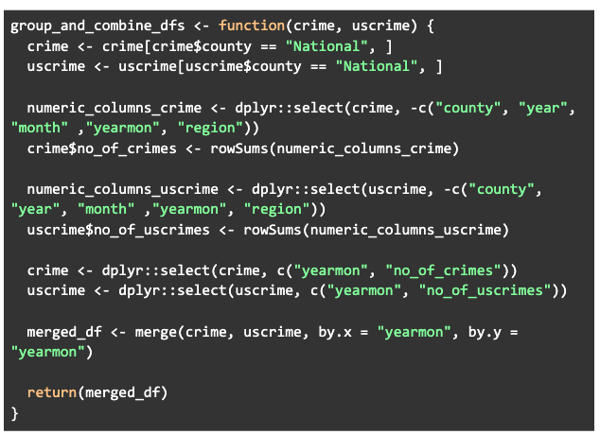

# 6. Predictive Analytics

Predictive analysis is a method of using data, statistical algorithms and machine learning techniques to identify the likelihood of future outcomes based on historical data. The goal of predictive analysis is to understand the data and to develop models that can make predictions or identify patterns and relationships that can be used to make decisions. We employ the listed predictive techniques:

* Regression
* Clustering
* Classification

## 6.1. Regression

Regression is a statistical method used to analyze the relationship between a dependent variable (also known as the response variable or outcome variable) and one or more independent variables (also known as predictor variables or explanatory variables). The goal of regression is to find the best-fitting line (or curve) that describes the relationship between the dependent variable and the independent variables. This line (or curve) is known as the regression line or model.

There are several different types of regression, including linear regression, multiple regression, logistic regression, and polynomial regression. We would be employing Linear & Multiple Regression.

### 6.1.1. Linear Regression

Linear regression is a statistical method that is used to model the relationship between a dependent variable (also known as the outcome or response variable) and one or more independent variables (also known as explanatory or predictor variables). It assumes that there is a linear relationship between the independent variables and the dependent variable, and tries to find the best fitting line through the data points.

#### 6.1.1.1. Dataset Summary

We would be going through the train and test dataset summaries for training the model and analyzing the results respectively. This is a summary of a datasets that contains two variables: yearmon and crimes. The variable "yearmon" is the date in the format of year-month, and the variable "crimes" is the number of crimes recorded for each date.

##### 6.1.1.1.1. Train

We can see that the minimum date is January 2014, and the minimum number of crimes recorded is 29,367. The median date is September 2015, and the median number of crimes recorded is 41,308. The maximum date is December 2017, and the maximum number of crimes recorded is 52,683.

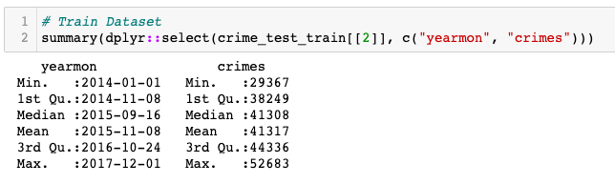

##### 6.1.1.1.2. Test

We can see that the minimum date is January 2018, and the minimum number of crimes recorded is 29,367. The median date is August 2018, and the median number of crimes recorded is 35,808. The maximum date is December 2018, and the maximum number of crimes recorded is 37,521.

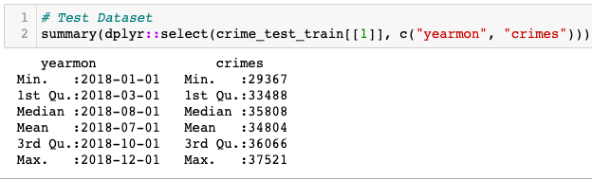

#### 6.1.1.2. Model Summary

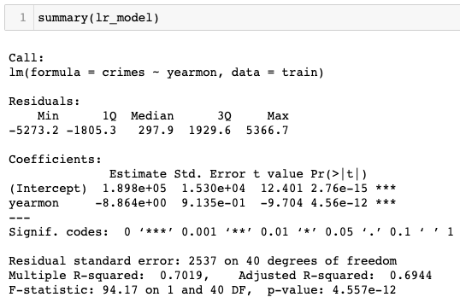

This is the summary of a linear regression model that is used to predict the number of crimes (dependent variable) based on the year and month (independent variable). The summary includes information about the coefficients of the model, the significance of the model, and the goodness of fit.

The coefficients table shows the estimates of the model's parameters. The first coefficient is the y-intercept (i.e. the predicted value of the dependent variable when the independent variable is zero) and is 189800. The second coefficient is the slope of the line, which is -8.864.

The t-value and p-value in the coefficients table indicate the significance of the coefficients. A small p-value (in this case p-value less than .05) indicates that the coefficient is statistically significant, and the t-value is used to test the null hypothesis of the coefficient being zero. A t-value greater than 2 in absolute value usually indicates that the coefficient is statistically significant.

The Residuals section shows the distribution of the residuals, which are the differences between the observed values of the dependent variable and the fitted (predicted) values. The Min, 1Q, Median, 3Q, and Max values give an idea of the range of residuals and whether they are symmetrically distributed.

The Residual standard error, R-squared, and the F-statistic are all measures of the goodness of fit. The residual standard error is a measure of the average deviation of residuals from zero, R-squared is a measure of the proportion of variation in the dependent variable that is explained by the independent variable, and the F-statistic is a measure of the overall significance of the model.

In this case, the R-squared of 0.7019 and the low p-value of the F-statistic (4.557e-12) indicates that the model has a good fit and it is able to explain 70.19% of the variance in the number of crimes.

#### 6.1.1.3. Accuracy Matrix

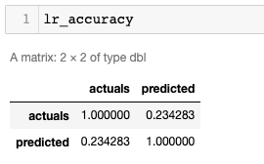

The accuracy matrix is showing the correlation between the actual values and the predicted values. The diagonal values (1.000000 and 1.000000) indicate that there is a perfect correlation between the actual and predicted values for the same class. The other value (0.234283) shows the correlation between the actual and predicted values for different classes. This correlation is relatively low, indicating that there is not a strong association between the actual and predicted values when they are different. This suggests that the model may not have a high level of accuracy in predicting the outcomes.

#### 6.1.1.4. Predicted vs Actual Plot

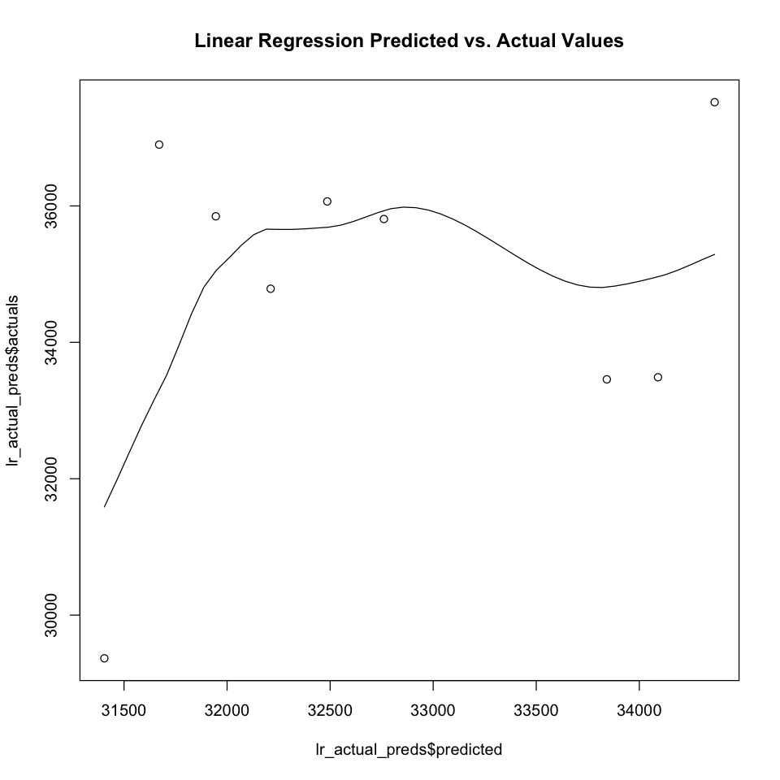

#### 6.1.1.5. Evaluating Stats

These values represent the difference between the predicted value and the actual value, with the MAE being the average of the absolute errors, the MSE being the average of the squared errors, and the RMSE being the square root of the MSE.

| MAE | 2723.76659024003 |
| --- | --- |
| MSE | 9546383.52268908 |
| RMSE | 3089.72224037843 |

#### 6.1.1.6. Code

##### 6.1.1.6.1. Split Data

This function takes a dataframe as input and separates it into two dataframes, one for testing and one for training. It first filters the dataframe to include only rows where the county column is "National", it converts yearmon column to date format and creates a new column called 'crimes' which is the sum of all numeric columns. Then it separates the dataframe into two dataframes based on the year column, where one dataframe includes only rows with year equal to 2018 which is used for testing and the other one includes all other years which is used for training. Finally, it removes unnecessary columns from both dataframes and returns a list containing test and train dataframe.

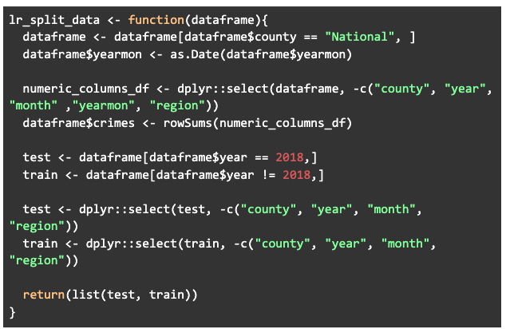

##### 6.1.1.6.2. Linear Regression

This function takes two dataframes as inputs (test and train) and uses them to perform a linear regression. It first fits a linear model using the lm() function with 'yearmon' as predictor and 'crimes' as response variable. Then, it uses the model to make predictions on the test data using the predict() function. It creates a new dataframe containing the actual values from the test data and the predicted values. Finally, it calculates the correlation between actual and predicted values using the cor() function and returns a list containing the model, the dataframe of actual and predicted values, and the correlation value.

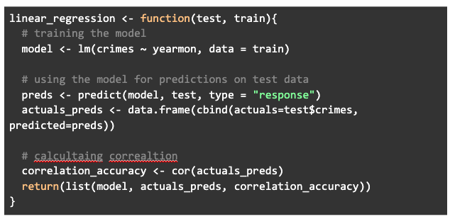

### 6.1.2. Multiple Regression

Multiple regression is a statistical technique that uses multiple independent variables to predict a single dependent variable. It is an extension of simple linear regression, which uses only one independent variable to predict a dependent variable. In multiple regression, the relationship between the independent variables and the dependent variable is represented by an equation with one dependent variable and multiple independent variables. The equation is used to predict the value of the dependent variable based on the values of the independent variables.

Multiple regression is useful for analyzing the relationship between multiple independent variables and a single dependent variable, and for understanding how changes in the independent variables affect the dependent variable. It is widely used in fields such as economics, psychology, and marketing to understand complex relationships between variables.

#### 6.1.2.1. Dataset Summary

This is a summary of the data in a dataframe, specifically the dataframe has 5 columns: 'county', 'year', 'month', 'crimes' and it's showing the summary statistics for each column.

##### 6.1.2.1.1. Train

The train dataset consists of dara from 2014, 2015, 2016, and 2017. The summary statistics for crimes are showing the minimum value of 70, first quartile of 476, median of 734, mean of 983.7, third quartile of 1107.2 and maximum of 8194.

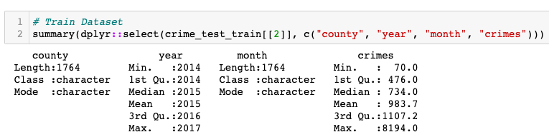

##### 6.1.2.1.2. Test

The train dataset consists of dara from 2018. The summary statistics for crimes are showing the minimum value of 190, first quartile of 408, median of 626, mean of 828.7, third quartile of 920.0 and maximum of 5400.

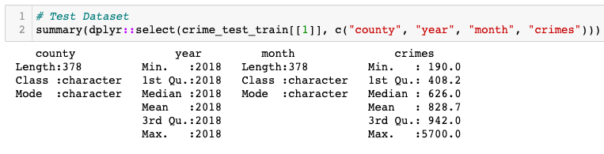

#### 6.1.2.2. Model Summary

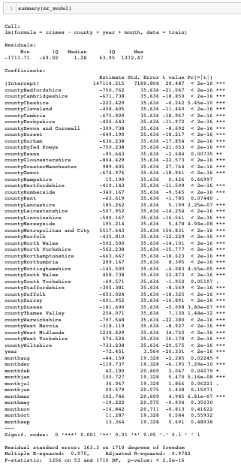

The model summary above describes a model that is used to predict the number of crimes based on the county, year, and month. The formula used to fit this model is "crimes ~ county + year + month" which means that the number of crimes is being predicted based on the county, year and month. The residuals section shows the minimum, first quartile, median, third quartile, and maximum values of the residuals which are the differences between the predicted values and the actual values. The coefficients section shows the estimate of the coefficients for each predictor variable, the standard error of the estimate, the t-value, and the p-value. The coefficients can be used to interpret the effect of each predictor variable on the response variable. The residual standard error is the standard deviation of the residuals and is used to measure the amount of error in the model. The multiple R-squared value is a statistical measure of how well the model fits the data. The F-statistic and p-value are used to test whether the overall model is significant. In this case, the model has a high R-squared value of 0.975, and a low residual standard error of 163.3, which indicates that the model has a good fit to the data, and the predictor variables are highly significant with p-value < 2.2e-16.

#### 6.1.2.3. Model Accuracy

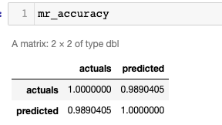

The matrix above represents the accuracy of the linear regression model. The first value in the top left corner represents the correlation between the actual values of the dependent variable (crimes) and the predicted values from the model. This value is 1, indicating a perfect correlation between the actual and predicted values. The second value on the top row represents the correlation between the actual values and the predicted values. This value is 0.9890405, which is very high and indicates that the model has a high degree of accuracy in predicting the dependent variable. The bottom left value represents the correlation between the predicted values and the actual values, which is also 0.9890405, which confirms the high accuracy of the model. The bottom right value represents the correlation between the predicted values and the predicted values, which is 1, indicating that the predicted values are perfectly correlated with themselves.

#### 6.1.2.4. Actual vs Predicted Plot

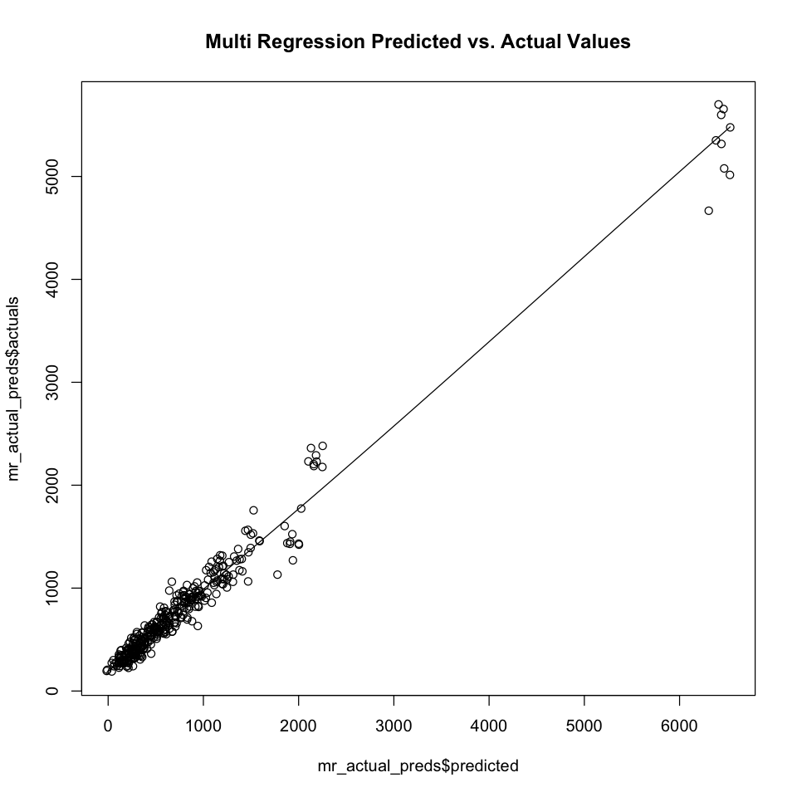

#### 6.1.2.5. Evaluating Stats

These values represent the difference between the predicted value and the actual value, with the MAE being the average of the absolute errors, the MSE being the average of the squared errors, and the RMSE being the square root of the MSE.

| MAE | 146.094951776508 |
| --- | --- |
| MSE | 55675.067652928 |
| RMSE | 235.955647639398 |

#### 6.1.2.6. Code

##### 6.1.2.6.1. Split Data

This function is used for splitting a given dataframe into a test and train dataset. It first filters out all rows that have "National" in the "county" column, then it creates a new column called "crimes" which is the sum of all numeric columns in the dataframe. It then filters the dataframe again to create a "test" dataset with only rows that have 2018 in the "year" column and a "train" dataset with all remaining rows. The function returns a list containing the test and train datasets.

| split_data <- function(dataframe){  dataframe <- dataframe[dataframe$county != "National", ]    numeric_columns_df <- dplyr::select(dataframe, -c("county", "year", "month" ,"yearmon", "region"))  dataframe$crimes <- rowSums(numeric_columns_df)   test <- dataframe[dataframe$year == 2018,]  train <- dataframe[dataframe$year != 2018,]   return(list(test, train)) } |
| --- |

##### 6.1.2.6.2. Multiple Regression

This function creates a multiple linear regression model using the 'county', 'year', and 'month' variables as predictors and 'crimes' variable as the response variable. The model is trained using the 'train' dataframe, and predictions are made on the 'test' dataframe. The function also calculates the correlation between the actual values and the predicted values of 'crimes' variable and returns the model, the actuals vs predicted values dataframe, and correlation accuracy.

| multiple_regression <- function(test, train){  # training the model   model <- lm(crimes ~ county + year + month, data = train)    # using the model for predictions on test data  preds <- predict(model, test, type = "response")  actuals_preds <- data.frame(cbind(actuals=test$crimes, predicted=preds))    # calcultaing correaltion   correlation_accuracy <- cor(actuals_preds)    return(list(model, actuals_preds, correlation_accuracy)) } |
| --- |

## 6.2. Clustering

Clustering is a technique used in unsupervised machine learning to group similar data points together. The goal of clustering is to find patterns or structure in the data by grouping similar observations into clusters. Clustering algorithms work by dividing a dataset into a specified number of clusters based on the similarity of the data points within each cluster. Clustering is often used in applications such as market segmentation, image compression, and anomaly detection. There are various clustering algorithms such as K-means, Hierarchical clustering, and DBSCAN etc. We would be working with K-Means and Hierarchical clustering.

### 6.2.1. KMeans

#### 6.2.1.1. Dataset Summary

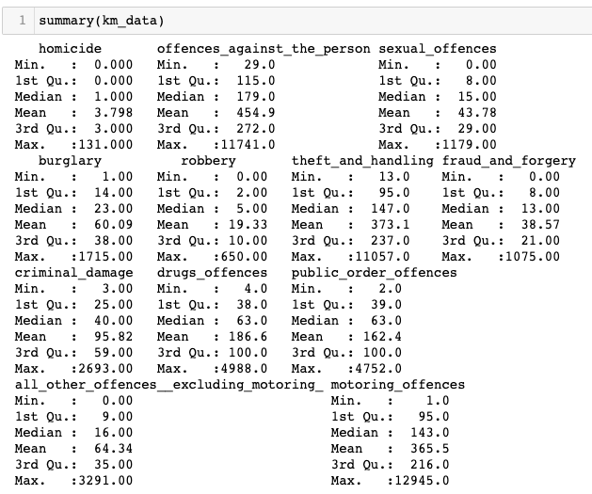

#### 6.2.1.2. With 4 Clusters

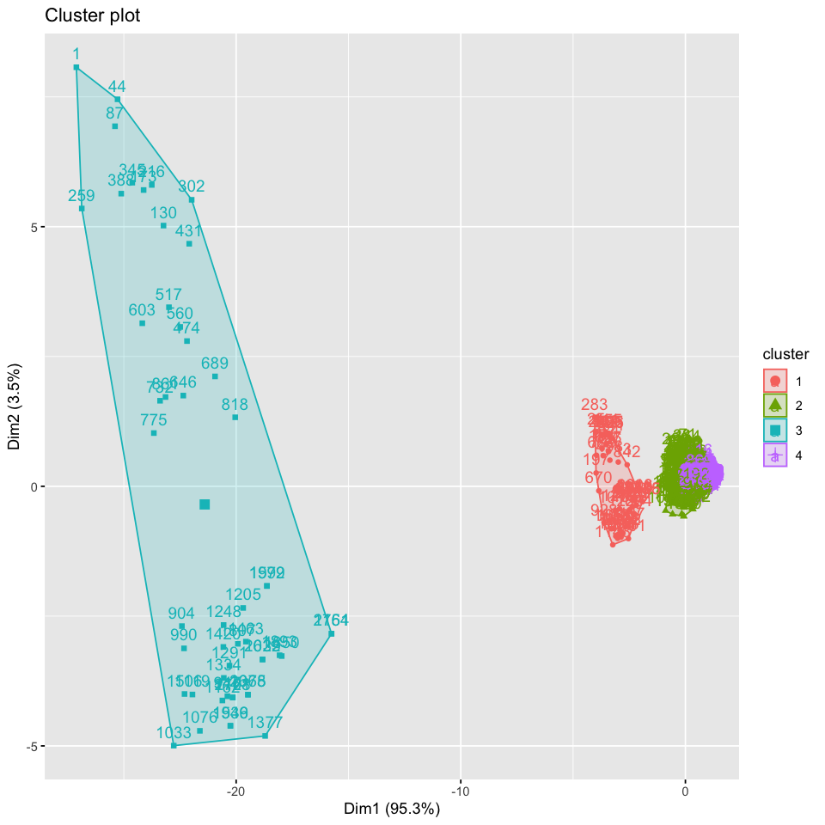

#### 6.2.1.3. With 5 Clusters

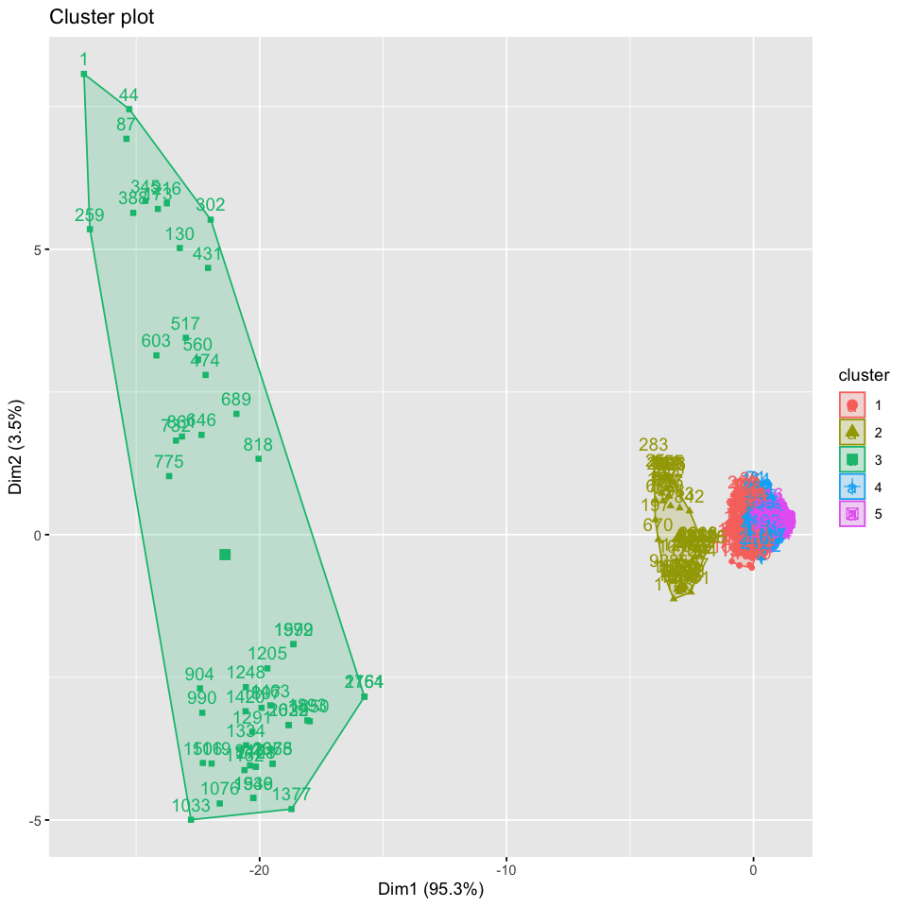

#### 6.2.1.4. With 6 Clusters

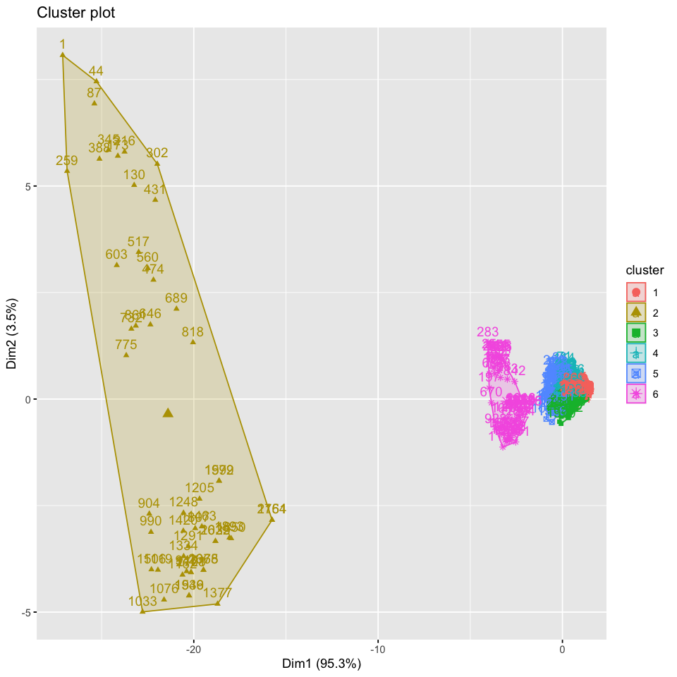

#### 6.2.1.5. Summary

Text Here

#### 6.2.1.6. Code

##### 6.2.1.6.1. Remove Non Numeric Columns

| remove_non_numeric_cols <- function(dataframe) {  dataframe <- dplyr::select(dataframe, -c("county", "year", "month" ,"yearmon", "region"))  return(dataframe) } |
| --- |

##### 6.2.1.6.2. K Means Clustering

| kmeans_clustering <- function(dataframe, clusters){  dataframe <- scale(dataframe)  model <- kmeans(dataframe, centers = clusters, nstart = 25)  return(model) } |
| --- |

### 6.2.2. Hierarchical Clustering

#### 6.2.2.1. Data Summary

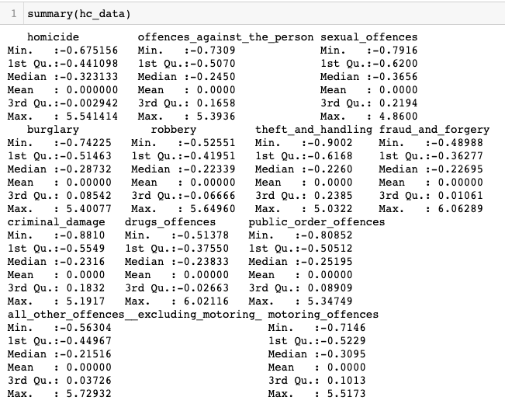

#### 6.2.2.2. Cluster Dendrogram

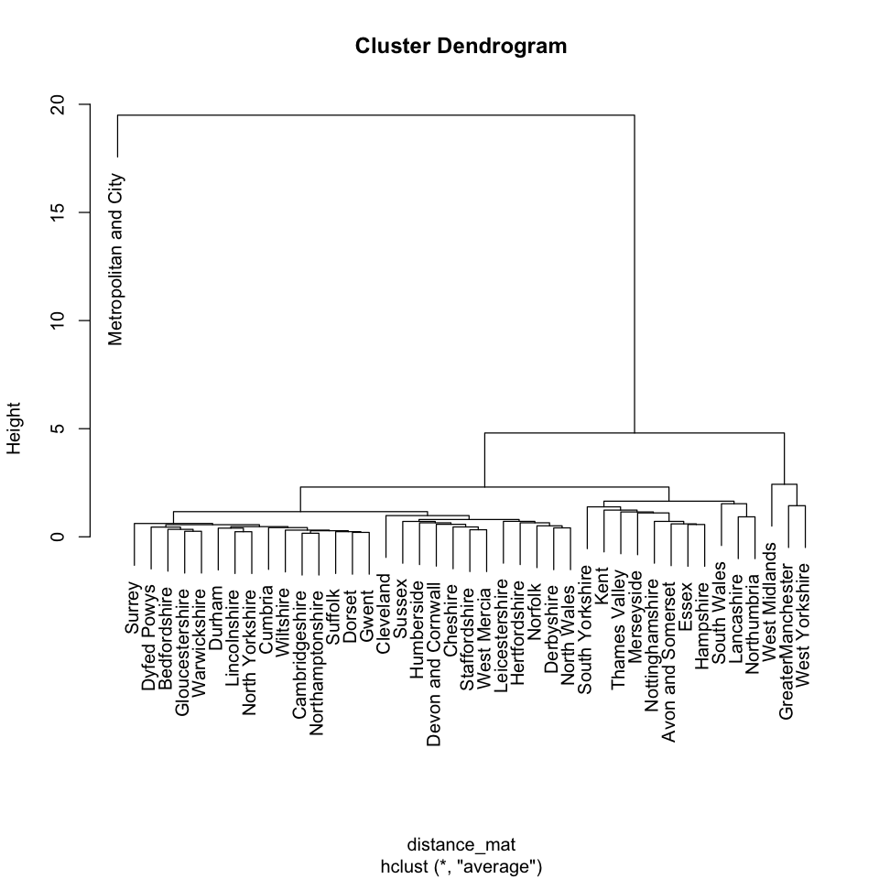

#### 6.2.2.3. Dendrogram with 2 Clusters

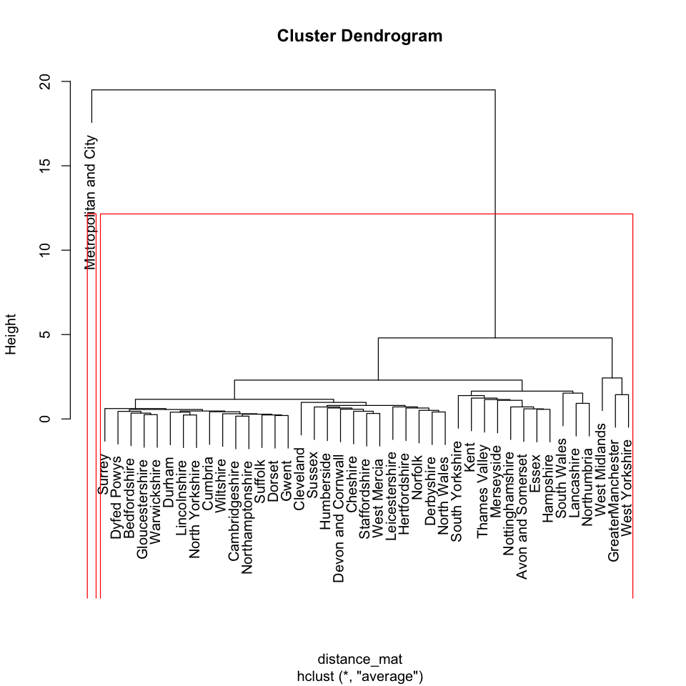

#### 6.2.2.4. Dendrogram with 3 Clusters

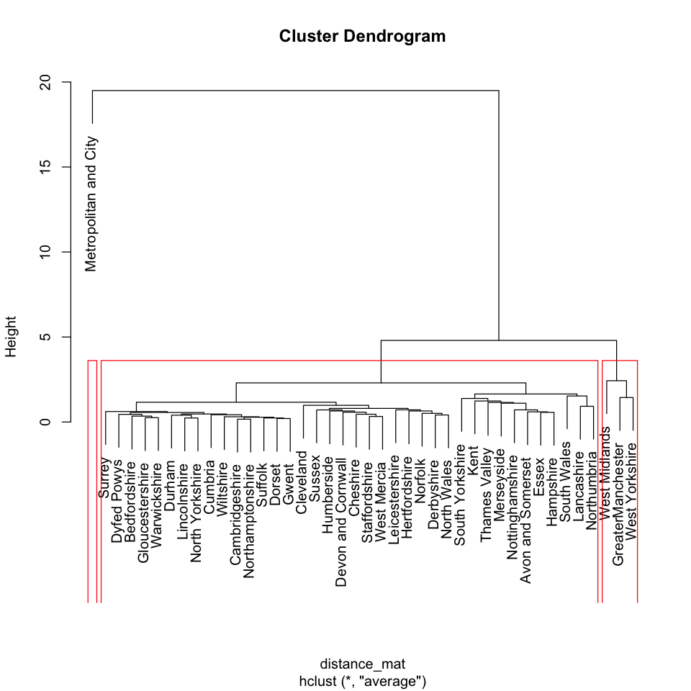

#### 6.2.2.5. Dendrogram with 5 Clusters

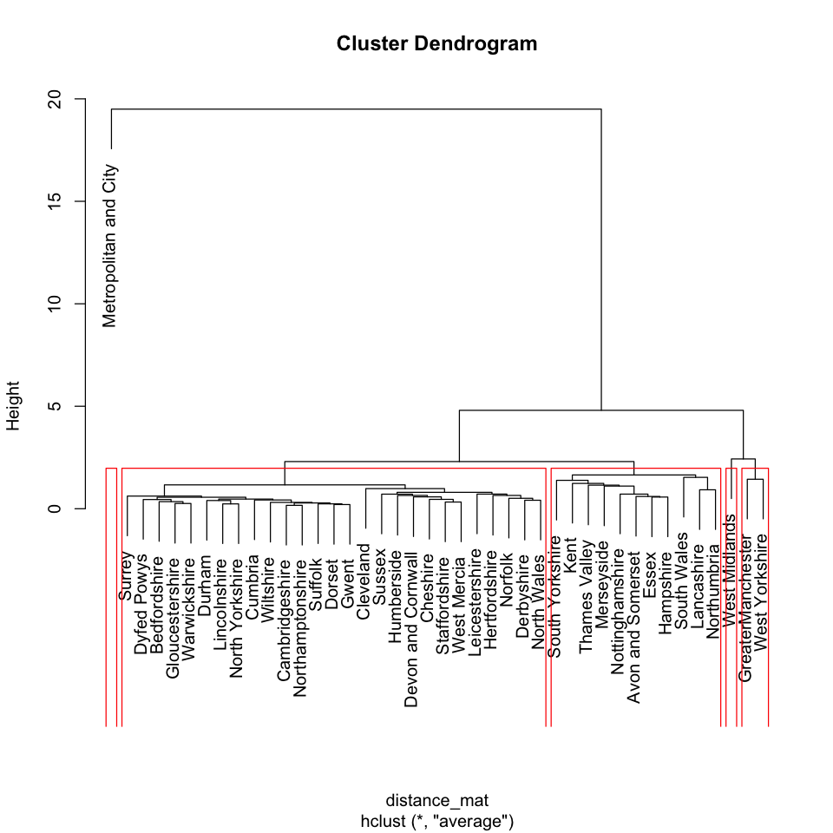

#### 6.2.2.6. Dendrogram with 8 Clusters

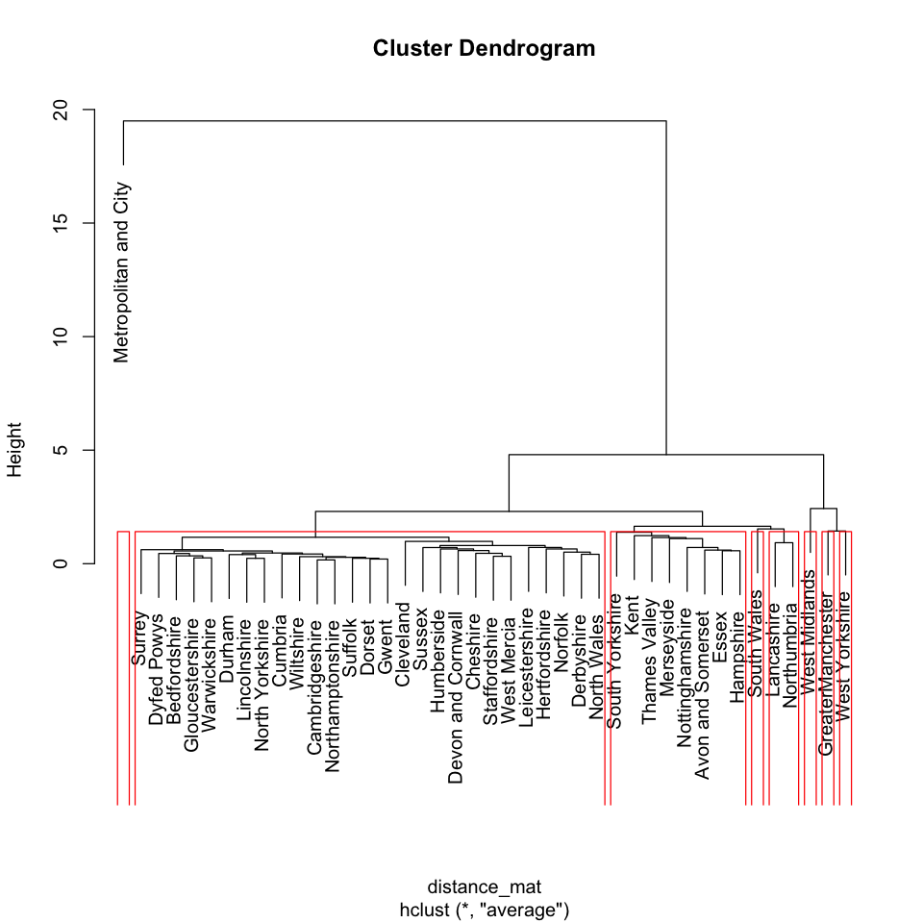

#### 6.2.2.7. Dendrogram with 11 Clusters

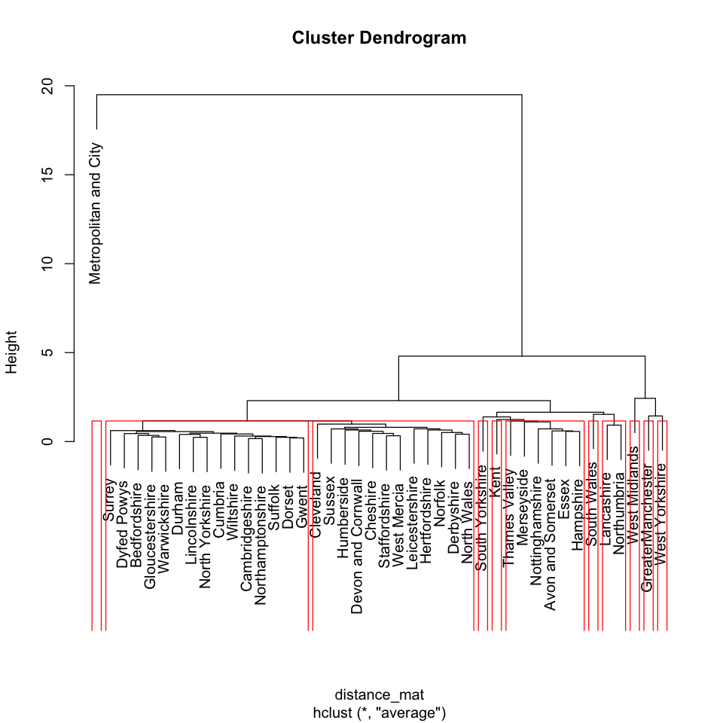

##### 6.2.2.7.1. Code

##### 6.2.2.7.2. Group By Country

| group_by_county <- function(dataframe){  dataframe <- dplyr::select(dataframe, -c("year", "month" ,"yearmon", "region"))  dataframe <- dataframe[dataframe$county != "National",]  dataframe <- group_by(dataframe, county)  dataframe <- summarise_all(dataframe, funs(sum))  dataframe2 <- dataframe[,-1]  rownames(dataframe2) <- dataframe$county  dataframe2 <- scale(dataframe2)  return(dataframe2) } |
| --- |

##### 6.2.2.7.3. HC Clustering

| hc_clustering <- function(dataframe) {  distance_mat <- dist(dataframe, method = 'euclidean')  set.seed(240)  model <- hclust(distance_mat, method = "average")  return(list(distance_mat, model)) } |
| --- |

## 6.3. Classification

### 6.3.1. SVM

#### 6.3.1.1. Dataset Summary

##### 6.3.1.1.1. Train

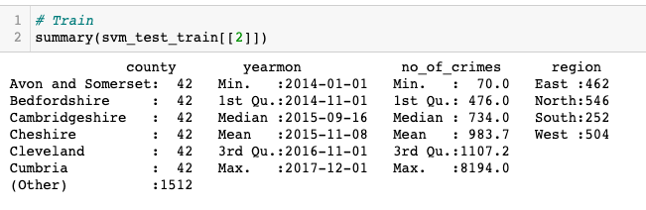

##### 6.3.1.1.2. Test

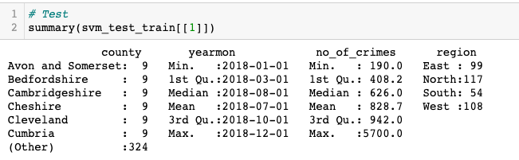

#### 6.3.1.2. Model Summary

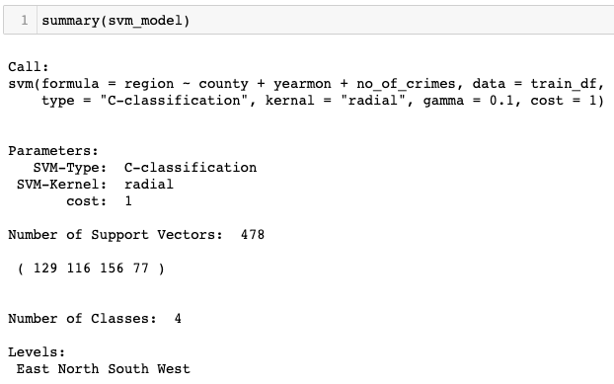

#### 6.3.1.3. Classification Report

| Confusion Matrix and Statistics   Reference Prediction East North South West  East 99 0 0 0  North 0 117 0 0  South 0 0 54 0  West 0 0 0 108  Overall Statistics    Accuracy : 1   95% CI : (0.9903, 1)  No Information Rate : 0.3095   P-Value [Acc > NIR] : < 2.2e-16     Kappa : 1     Mcnemar's Test P-Value : NA   Statistics by Class:   Class: East Class: North Class: South Class: West Sensitivity 1.0000 1.0000 1.0000 1.0000 Specificity 1.0000 1.0000 1.0000 1.0000 Pos Pred Value 1.0000 1.0000 1.0000 1.0000 Neg Pred Value 1.0000 1.0000 1.0000 1.0000 Prevalence 0.2619 0.3095 0.1429 0.2857 Detection Rate 0.2619 0.3095 0.1429 0.2857 Detection Prevalence 0.2619 0.3095 0.1429 0.2857 Balanced Accuracy 1.0000 1.0000 1.0000 1.0000 |
| --- |

#### 6.3.1.4. Model Roc

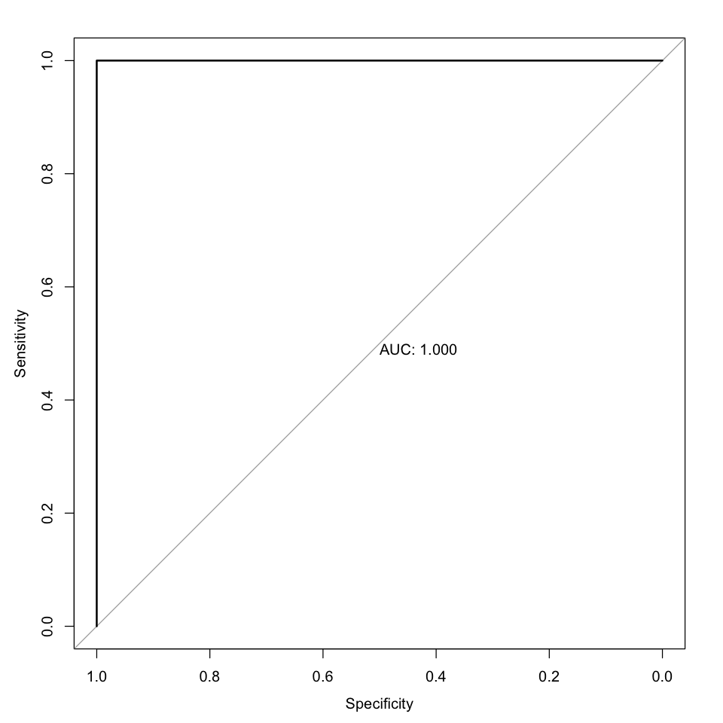

#### 6.3.1.5. Code

##### 6.3.1.5.1. SVM Model Generate

| svm_model_generate <- function(train_df, test_df) {  set.seed(123)    svm_model <- svm(region ~ county + yearmon + no_of_crimes, data = train_df, type = 'C-classification', kernal = "radial", gamma = 0.1, cost = 1)    test_predictions <- predict(svm_model, test_df)  confusion_matrix <- confusionMatrix(as.factor(test_predictions), as.factor(test_df$region))  model_roc = multiclass.roc(test_df$region ~ as.numeric(as.factor(test_predictions)), plot=TRUE, print.auc = TRUE)   return(list(svm_model, confusion_matrix)) } |
| --- |

### 6.3.2. Random Forest

#### 6.3.2.1. Dataset Summary

##### 6.3.2.1.1. Train

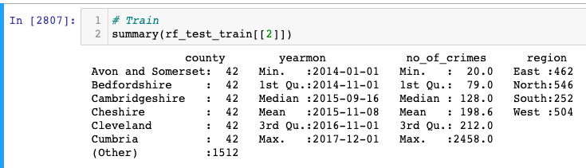

##### 6.3.2.1.2. Test

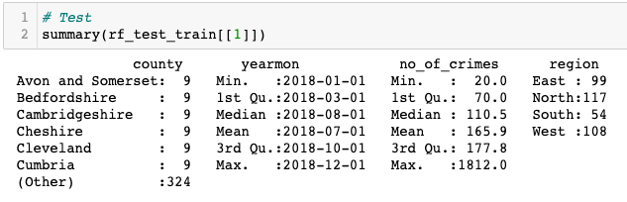

#### 6.3.2.2. Model Summary

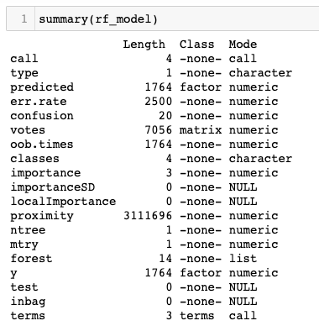

#### 6.3.2.3. Classification Report

| Confusion Matrix and Statistics   Reference Prediction East North South West  East 99 0 0 0  North 0 117 0 0  South 0 0 54 0  West 0 0 0 108  Overall Statistics    Accuracy : 1   95% CI : (0.9903, 1)  No Information Rate : 0.3095   P-Value [Acc > NIR] : < 2.2e-16     Kappa : 1     Mcnemar's Test P-Value : NA   Statistics by Class:   Class: East Class: North Class: South Class: West Sensitivity 1.0000 1.0000 1.0000 1.0000 Specificity 1.0000 1.0000 1.0000 1.0000 Pos Pred Value 1.0000 1.0000 1.0000 1.0000 Neg Pred Value 1.0000 1.0000 1.0000 1.0000 Prevalence 0.2619 0.3095 0.1429 0.2857 Detection Rate 0.2619 0.3095 0.1429 0.2857 Detection Prevalence 0.2619 0.3095 0.1429 0.2857 Balanced Accuracy 1.0000 1.0000 1.0000 1.0000 |
| --- |

#### 6.3.2.4. Model Roc



#### 6.3.2.5. Code

##### 6.3.2.5.1. Rf Model Generate

| rf_model_generate <- function(train_df, test_df) {  set.seed(123)    rf_model <- randomForest(region ~ county + yearmon + no_of_crimes, data = train_df, proximity=TRUE)    test_predictions <- predict(rf_model, test_df)  confusion_matrix <- confusionMatrix(as.factor(test_predictions), as.factor(test_df$region))  model_roc = multiclass.roc(test_df$region ~ as.numeric(as.factor(test_predictions)), plot=TRUE, print.auc = TRUE)   return(list(rf_model, confusion_matrix)) } |
| --- |

### 6.3.3. Summary

### 6.3.4. Joint Code

| classify_split_data <- function(dataframe){  dataframe <- dataframe[dataframe$county != "National", ]  dataframe$yearmon <- as.Date(dataframe$yearmon)  dataframe$region <- as.factor(dataframe$region)  dataframe$county <- as.factor(dataframe$county)    numeric_columns_df <- dplyr::select(dataframe, -c("county", "year", "month" ,"yearmon", "region"))  dataframe$no_of_crimes <- rowSums(numeric_columns_df)    test <- dataframe[dataframe$year == 2018,]  train <- dataframe[dataframe$year != 2018,]   test <- dplyr::select(test, c("county", "yearmon" ,"no_of_crimes" ,"region"))  train <- dplyr::select(train, c("county", "yearmon", "no_of_crimes" ,"region"))      return(list(test, train)) } |
| --- |

### 

# 7. Time Series Analytics

### 7.0.1. Crime

#### 7.0.1.1. Dataset Summary

##### 7.0.1.1.1. Data Frame

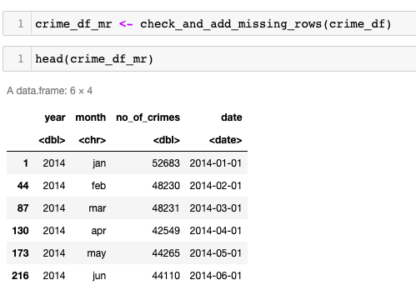

##### 7.0.1.1.2. Time Series

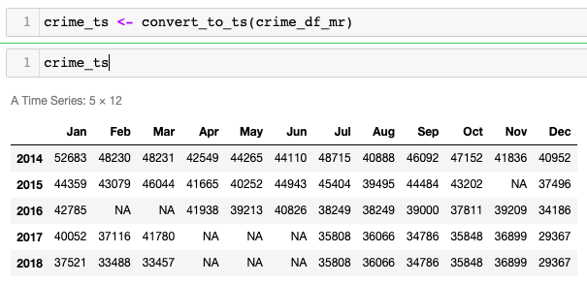

#### 7.0.1.2. Time Series Data Plot

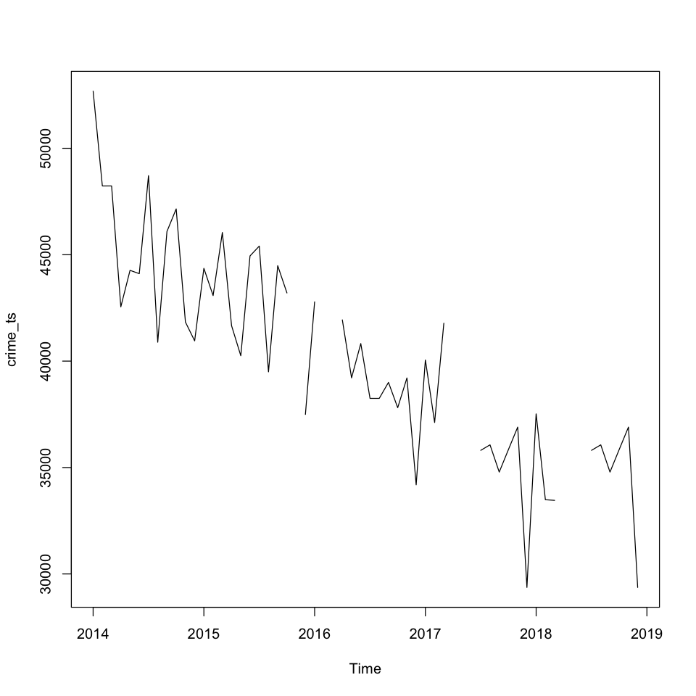

#### 7.0.1.3. Filling Missing Data with Mice

##### 7.0.1.3.1. Mice Summary

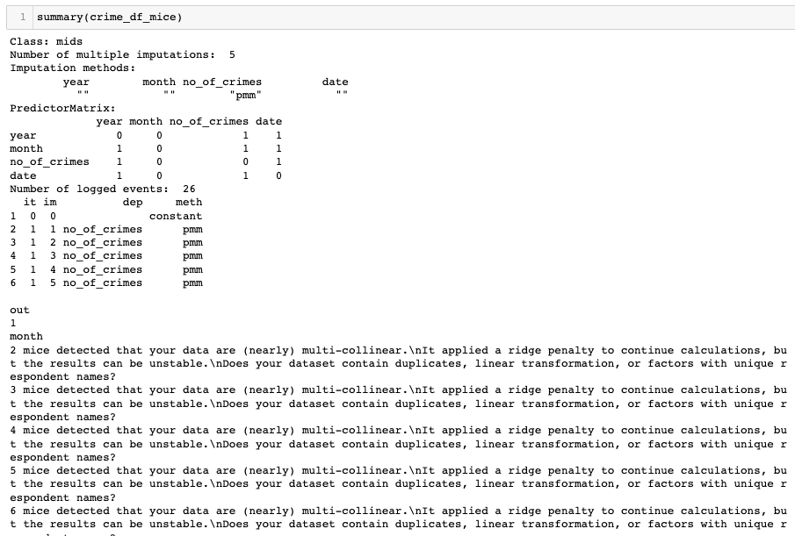

##### 7.0.1.3.2. Mice Filled Data

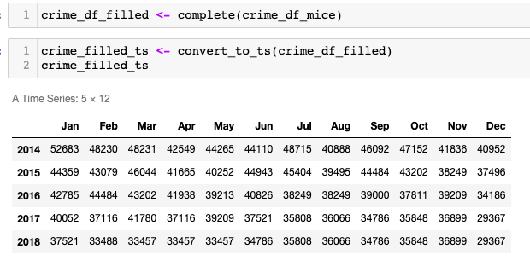

#### 7.0.1.4. Filled Time Series Data Plot

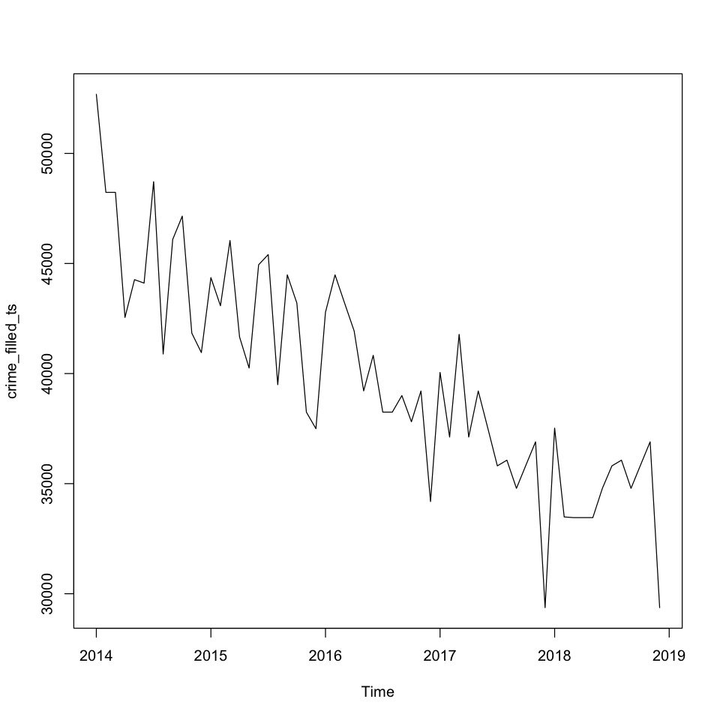

#### 7.0.1.5. Data Patterns Check

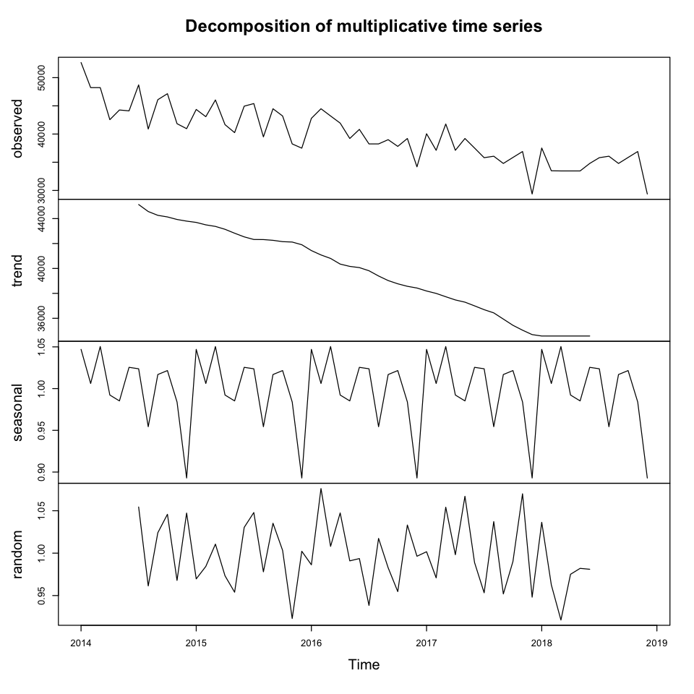

#### 7.0.1.6. Diagnostic Check

##### 7.0.1.6.1. Residuals

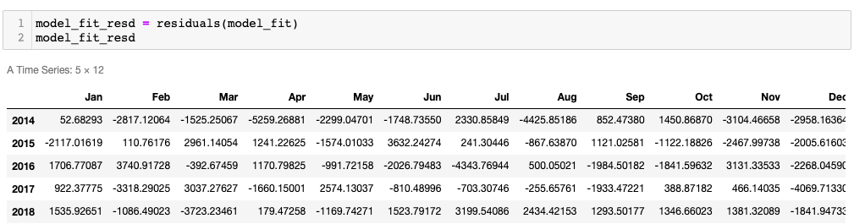

##### 7.0.1.6.2. Box-Ljung test

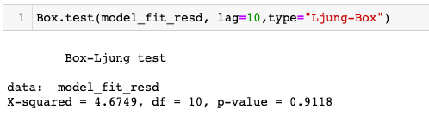

#### 7.0.1.7. Forecasting

##### 7.0.1.7.1. Years

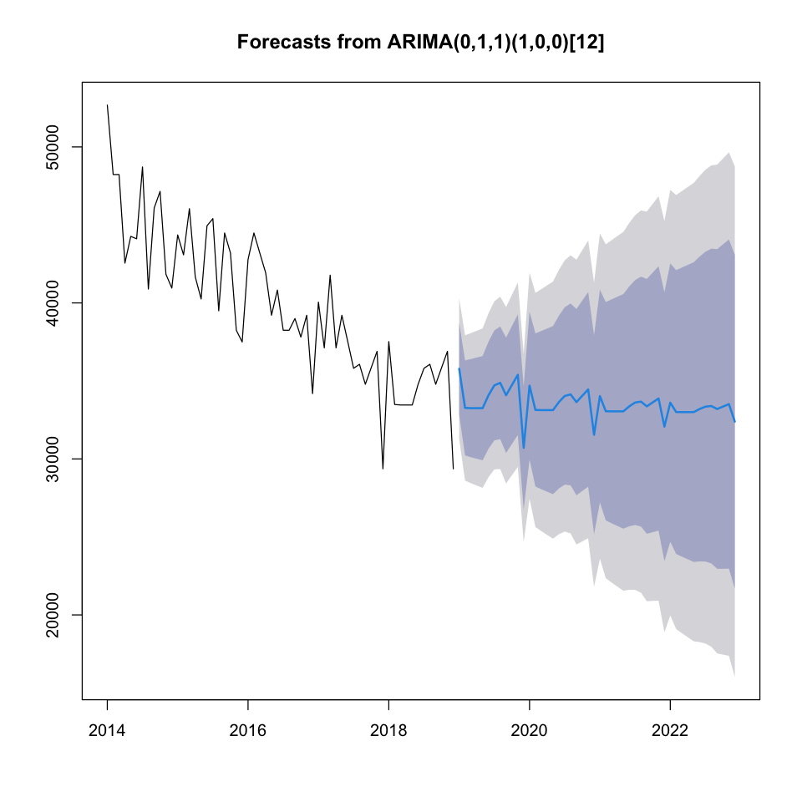

##### 7.0.1.7.2. Years

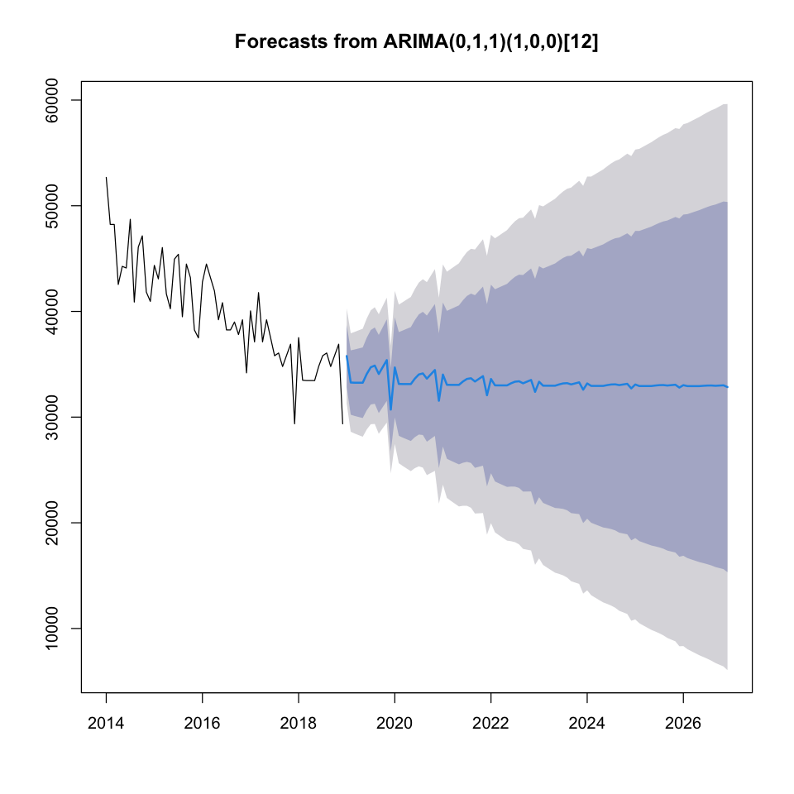

### 7.0.2. Un successful Crimes

#### 7.0.2.1. Dataset Summary

##### 7.0.2.1.1. Data Frame

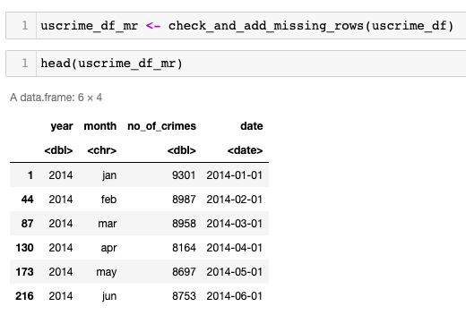

##### 7.0.2.1.2. Time Series

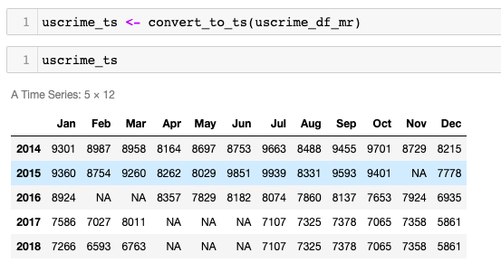

#### 7.0.2.2. Time Series Data Plot

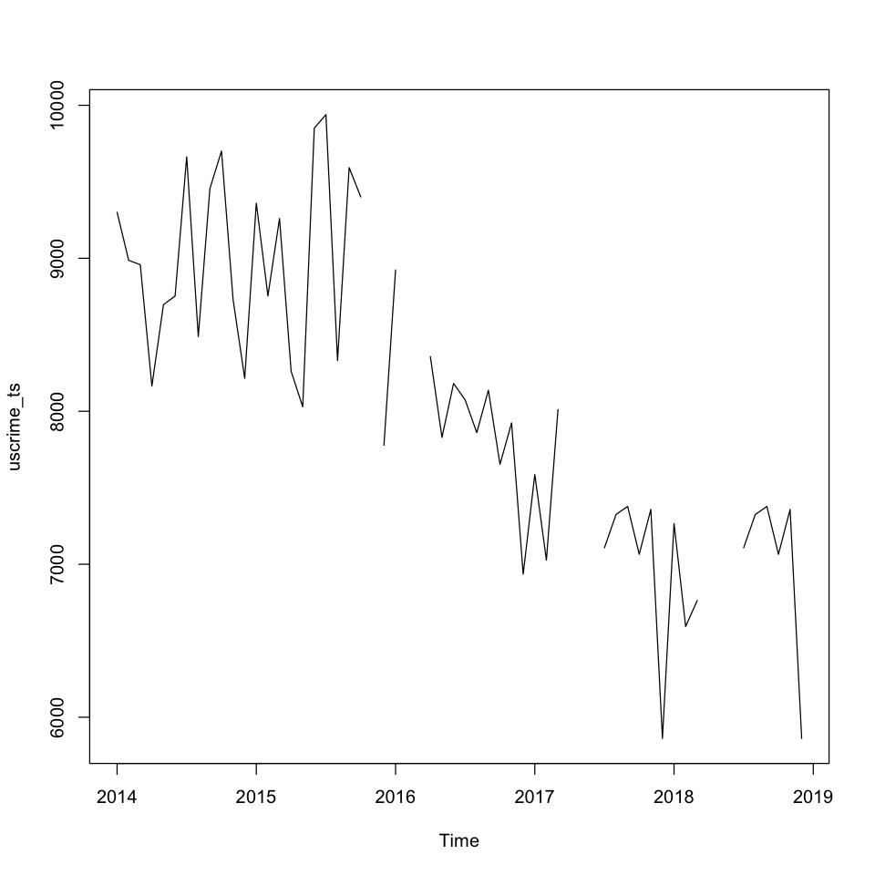

#### 7.0.2.3. Filling Missing Data with Mice

##### 7.0.2.3.1. Mice Summary

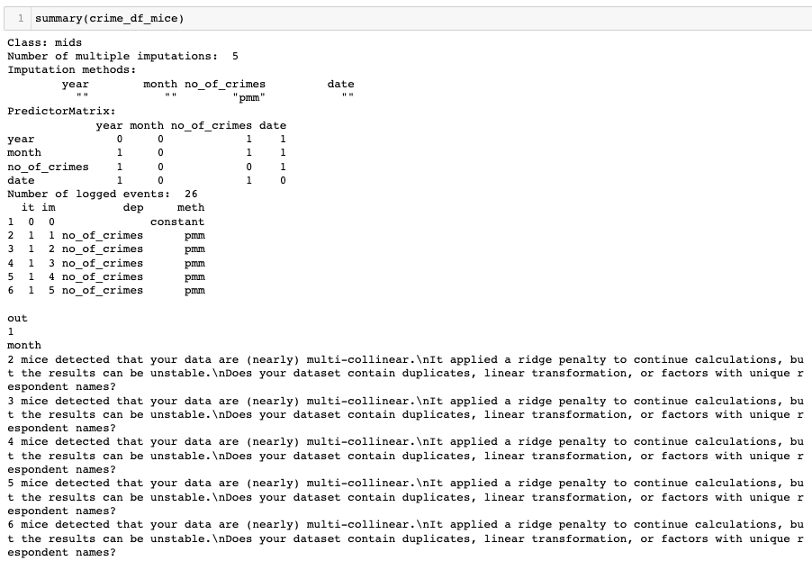

##### 7.0.2.3.2. Mice Filled Data

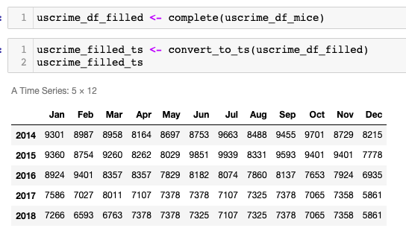

#### 7.0.2.4. Filled Time Series Data Plot

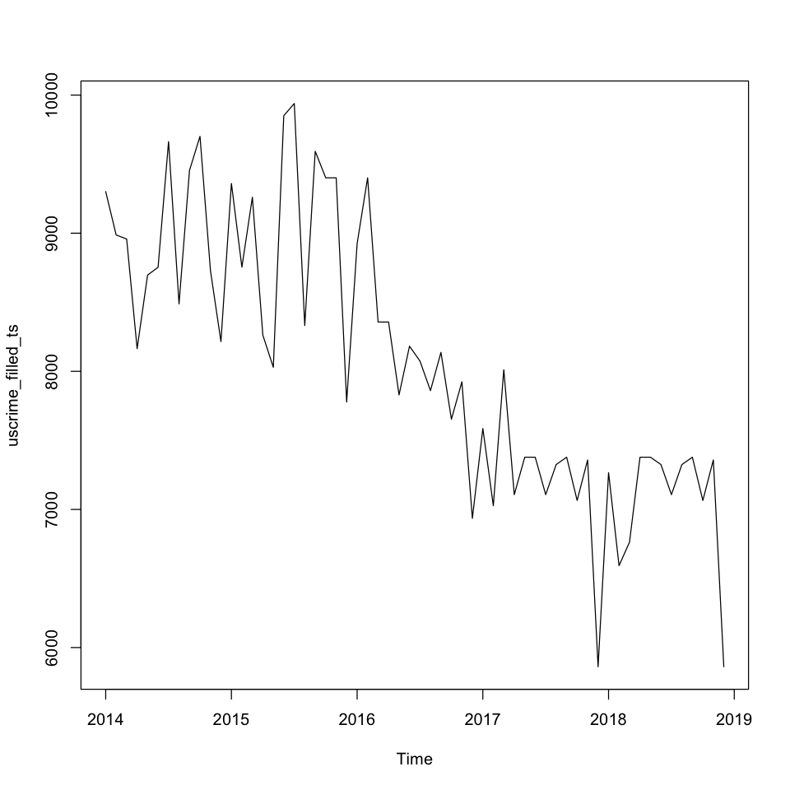

#### 7.0.2.5. Data Patterns Check

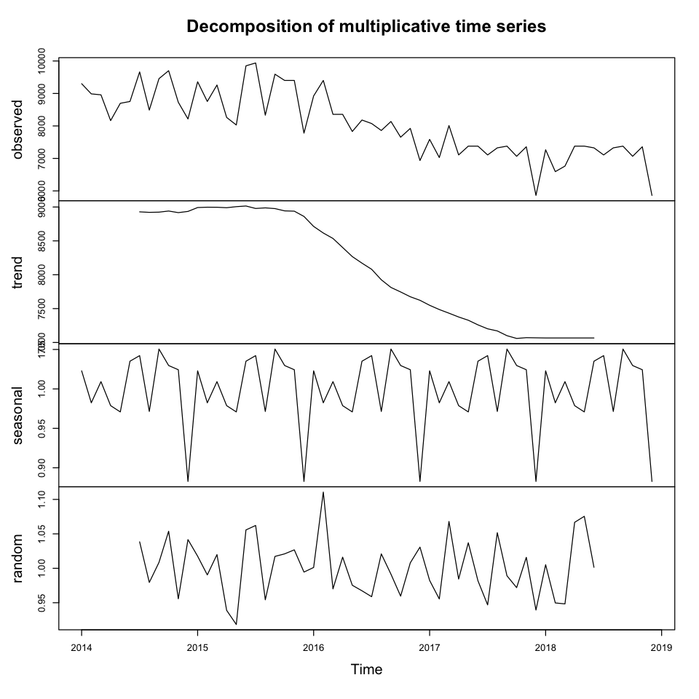

#### 7.0.2.6. Diagnostic Check

##### 7.0.2.6.1. Residuals

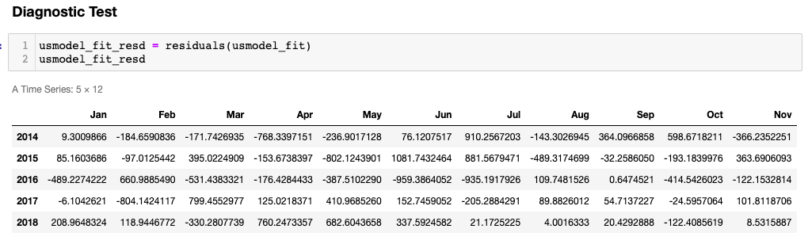

##### 7.0.2.6.2. Box-Ljung test

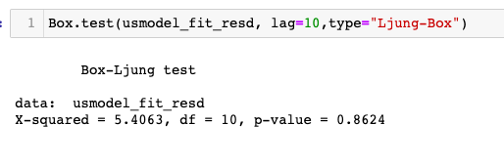

#### 7.0.2.7. Forecasting

##### 7.0.2.7.1. Years

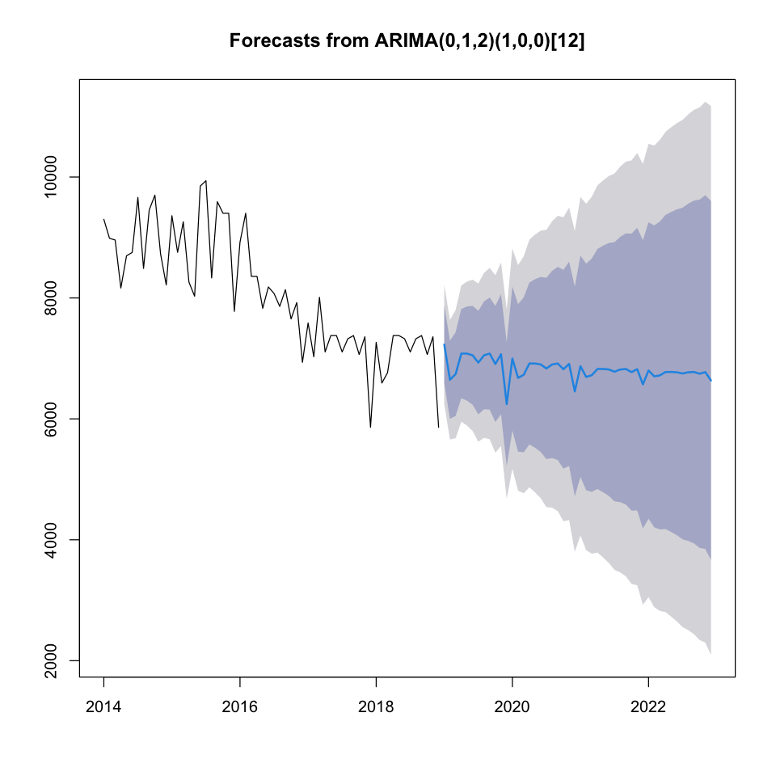

##### 7.0.2.7.2. Years



### 7.0.3. Summary

### 7.0.4. Joint Code

##### 7.0.4.0.1. Check and Add Missing Rows with NA

| check_and_add_missing_rows <- function(dataframe){  dataframe <- dataframe[dataframe$county == "National",]    numeric_columns_df <- dplyr::select(dataframe, -c("county", "year", "month" ,"yearmon", "region"))  dataframe$no_of_crimes <- rowSums(numeric_columns_df)  df <- dplyr::select(dataframe, c("year", "month","no_of_crimes"))   unique_years <- c(2014, 2015, 2016, 2017, 2018)  months <- c("jan", "feb", "mar", "apr", "may", "jun", "jul", "aug", "sep", "oct", "nov", "dec")  for(year in unique_years){  missing_months <- setdiff(months, df$month[df$year == year])  for(missing_month in missing_months){  new_row <- data.frame(year = year, month = missing_month, no_of_crimes = NA)  df <- rbind(df, new_row)  }  }    df$date <- as.Date(paste(df$year, df$month, "01", sep = "-"), "%Y-%b-%d")  df <- df[order(df$date),]    return(df) } |
| --- |

##### 7.0.4.0.2. Convert to Time Series

| convert_to_ts <- function(df){  months <- c("jan", "feb", "mar", "apr", "may", "jun", "jul", "aug", "sep", "oct", "nov", "dec")  ts_obj <- ts(df$no_of_crimes, start = c(df$year[1], match(df$month[1], months)), frequency = 12)   return(ts_obj) } |
| --- |

### 

# 8. References